Amani Abraham
Social Role of Mass Media
Avoiding Fake News Lesson
Lesson Title: Avoiding Fake news

Description of the lesson: With an overflow of information, it’s important to identify what’s accurate and what is “fake.” Do you know if what you’re reading is true? Are there sources to trace back to confirm information presented in a publication?

Verifying the news material we come across has become more important than years past, in part because nearly anyone can post information online and claim that the information is legit. This lesson will help you with the basic steps to identify “fake news.”

Objectives
by the end of this lessons, students will be able to ..

- Identify the tools that can be used to determine whether news material contains misinformation.

Before moving forward, review the tools that can help to avoid fake news:
- How to spot fake news (IFLA)
- Learning To Spot Fake News: Start With A Gut Check
- A guide to spotting fake news
- Using reverse image search on your phone

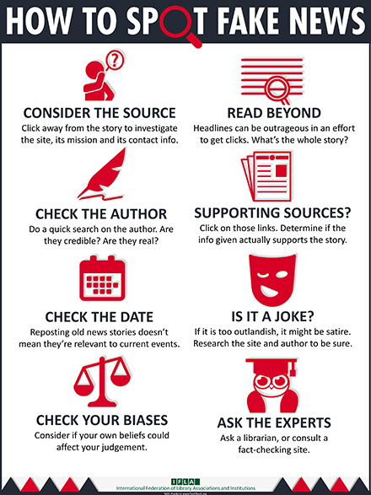
Courtesy: IFLA.org and FactCheck.org

Procedures:

- Read the text that below and save the photo below to your desktop.

5 million attend Trump rally in Phoenix, Arizona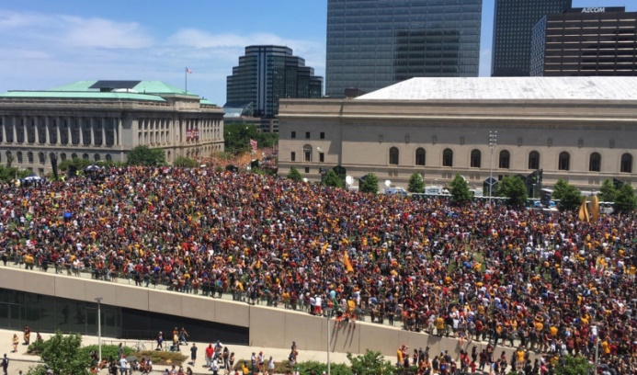
Trump supporters gather to watch the presidential candidate’s final campaign speech in downtown Phoenix Wednesday.

- Using the Google reverse image search, identify where this photo was originally published.
  - Was it easy to find its source?
  - The photo above was used as the lead image to identify the crowd size of a Donald Trump rally. Click here to see how the story looked when it was published before it was eventually deleted.

- Take a look at this online story that was published days after the Florida school shooting that left 17 dead on Feb. 14, 2018. Identify whether this is a valid news article and determine whether you believe it should be considered “fake news.” Explain your argument in a Word document by identifying the tools you used to determine the publication’s accuracy. Answer the questions below:
  - What is the source of both the publication and attributed information in the article?
  - What information is confirmed? Are there any facts? How do you know?
  - Who is the author of the article? Is there a possible agenda? If so, explain.
  - Is there a bias represented in the article? If so, explain.

