HOW TO: CAPTIONS/CUTLINES

- What does a cutline provide to a story?
  - Cutlines are used to help identify the subjects in your photo, as well as provide additional details (including date and location) and context for the reader.

- What to include:
  - Cutlines/Captions should include the subject and action in the photo, along with the date. The cutlines should be brief, but provide context to the photo and story.
  - Name, age of subject (check spelling)
  - Location
  - Date

- Cutlines should be written by the photographer who captured the image. The cutlines are then reviewed by the photo editor before it’s moved through publishing.

EXAMPLE:

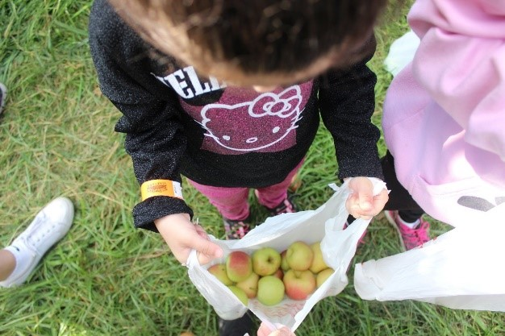

Sophia Abraham, 4, counts the apples she picked during a family outing at Great Country Farms in Bluemont, VA on Oct. 20, 2018. The apples, along with sunflowers at a field nearby, will be available for picking through the month of October.

