Media Ethics Example
Case #3
- If the president says “bullshit,” how do you report on it?
- READ: Trump’s ‘BULLSHIT’ Tweet Is Pushing Vulgarity Into CNN’s Daytime Broadcast (Again)
- READ: After Donald Trump Said It, How News Outlets Handled It
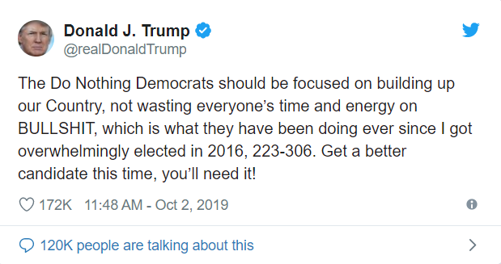

ACTIVITY: What do you do?
  - The alert of the president’s tweet comes across your screen. How do you approach this as a journalist?
    - What is the news value of the quote?
      - What is your policy on expletives?
      - When is it okay to use for publication?
  - After reading the articles above, would you have handled the events as the media handled it in both cases?
    - Describe your reasoning.
    - What would you have done?
  - REACTION:
    - Major news organizations have policies regarding the use of expletives Generally, you’ll find policies that discourage the publication of expletives. But each case should be weighted on its own to determining its news value. Who is saying it and does the word(s) offer context or additional information regarding the subject’s character and/or thoughts? These decisions should be made with your editors during thoughtful discussions.

