Media Ethics Example
Case #4:
- This Facebook post was circulated online on Facebook.
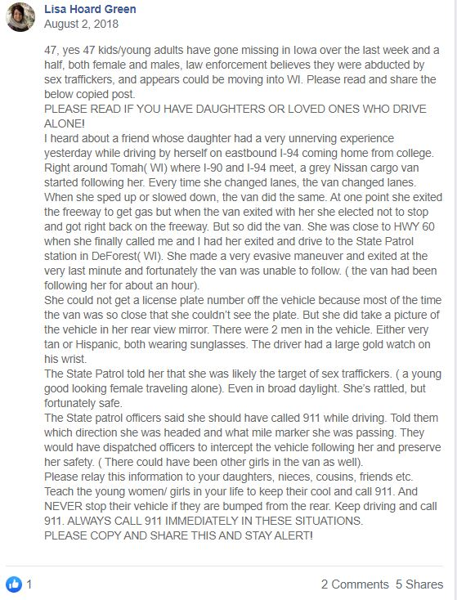
Questions:
- What do you do?
  - Do you immediately share and report?
  - How do you verify the information?
  - Are you familiar with the source sharing the information?
  - Are police aware?
READ/WATCH: Facebook posts spreading sex trafficking fears in Midwest
REACTION:
- This Facebook post is similar to many that have been shared thousands of times across the country. How can we be responsible journalists as we work to verify information as quickly as rumors spread? It’s not enough to be journalists that “break news.” Journalists need to showcase their verification skills and focus on accuracy.
- In this case, it’s critical to try to confirm information with official sources. Calling a local police department to verify the information can quickly dispel rumors and ease concerns within a community.
- Pay attention to posts that read “copy and share.” What’s the motive here?
- Are the claims outrageous? Remain skeptical until information can be clearly verified.

