CASE #5:
READ: When a private tragedy becomes a public spectacle: Public Editor
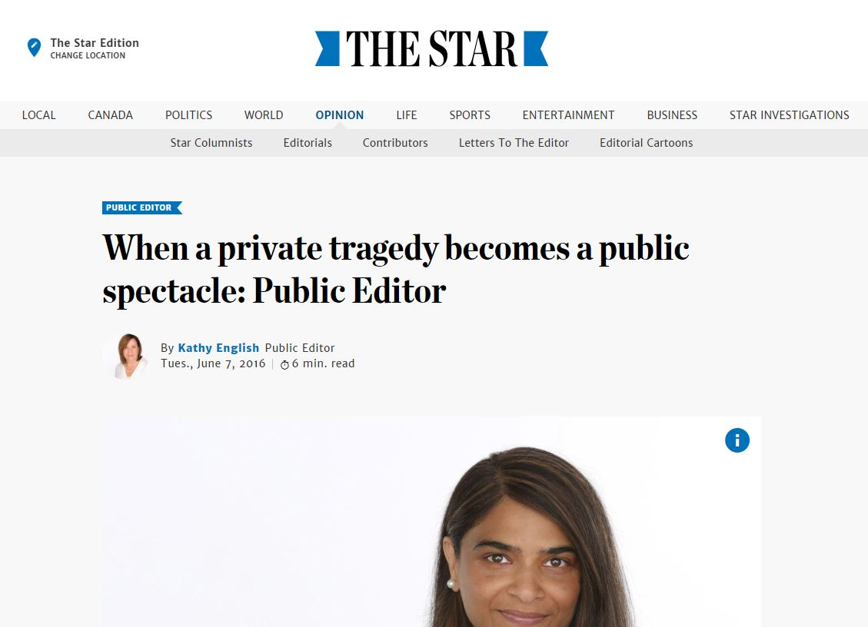
Summary: Despite the newspaper’s policy to generally not report on suicides, the editor made a decision to publish a story detailing a reporter’s suicide and the investigation that followed.

ACTIVITY: What do you do?
- If you’re the newspaper, what do you do?
  - If the union is calling for an investigation, does the story hold a unique position?
  - Why would it be of interest to the public?
  - How do you feel about going against the family’s wishes in this case?
  - How, if at all, would
- REACTION:
  - Suicides are a sensitive issue. Each case may be handled differently depending on its impact on the public. As journalists, it’s important to weigh all of the factors of why it should or shouldn’t be publicly addressed. In this case, it appears the editor felt the call for an investigation required transparency in the newsroom, going against the wishes of the family to address the union’s call for action.

