Personal Vs. Public
(Ethical presentation on social media as a journalist)

READ:
- Media Ethics, page 175, Case 4-C
- ESPN Suspends Jemele Hill Two Weeks for Violating Social Media Policy
- Jemele Hill opens up about her suspension: 'I put ESPN in a bad spot'

ACTIVITY:
- Read the case of Jamele Hill and her tweets:
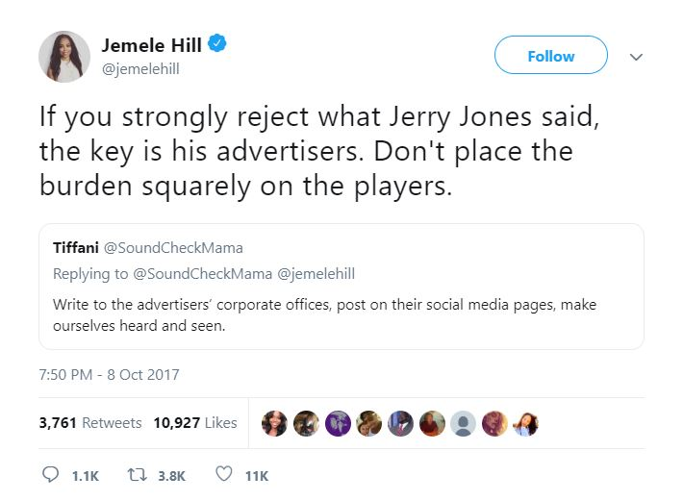

  - Students will work in groups to discuss the issues and answer the following questions:
    - How should journalists use their personal and public accounts? Should journalists be allowed to say whatever they want on their personal accounts?
    - When could it be an issue?
    - Why could it be an issue?

ACTIVITY 2:
- Students should work in groups of three to develop a social media policy for journalists when using their personal and public social media accounts.
  - What guidelines should they follow to remain ethical?
  - View the course statements on handling social media.
    - Why would guidelines be newscast for journalists?
    - Who and how do their actions online impact others?

