The Ethics of News Aggregation
READ:
- Media Ethics, Page 102, Case 2-H
- What’s the law around aggregating news online? A Harvard Law report on the risks and the best practices
- 4 guidelines for aggregating news content

ACTIVITY:

- What is news aggregation?
  - Have students explore aggregation websites like Feedly.com and News360.

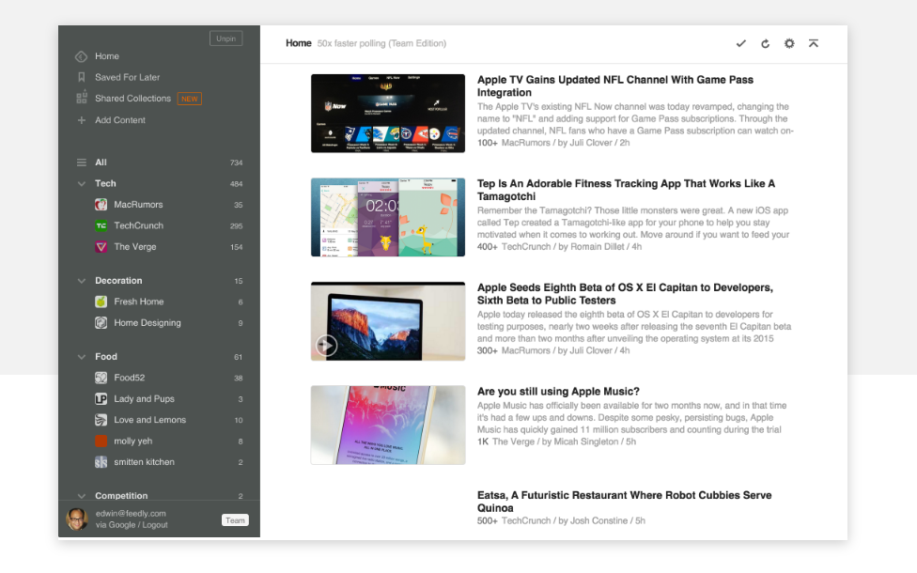
- What do they notice? How are headlines written? How do some local news organizations aggregate material? Show examples:
- Why do you think news organizations are aggregating material?
  - Low resources and staff.
- What are some ethical issues related to news aggregation?
  - Answer the following questions as presented in Media Ethics: Issues and Cases textbook.
    - Does proper attribution solve the ethical problem of aggregation? If not, do you have an alternative idea?
    - If news organizations voluntarily agree to offer their content to be aggregated under specific conditions, does that eliminate the ethical issues?
ACTIVITY 2:
- Read Poynter’s “4 guidelines for aggregating news content.”
  - Students will write a brief position paper on their thoughts to maintain ethical standards through aggregation.

