Lesson Title: Blogging about your reporting journey

Description of the lesson: Social media can be used to share both verified and unverified information, but it’s also a tool to encourage transparency when reporting. In this lesson, students will create a blog that openly shares their reporting process during a topic of their choice.

Objectives
by the end of this lessons, students will be able to ..

- Understand how to organize and present your fact-gathering process during a reporting assignment.
- Explain the role mirror and candle theories play in journalism.

Procedures:

Before beginning on your blog, read the following:
    - Benefits blogging brings to news outlets
    - Blogs and Journalism Need Each Other

- Launch your blog using WordPress:
  - Follow the instructions to create your blog and pick a title that will correspond to your reporting field. NOTE: You do not need to purchase a domain name.

  - 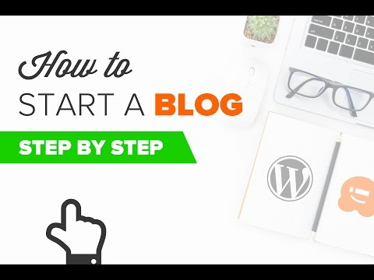

- The content of your blog should include the following:
  - Homepage that identifies who you are (headshot included) and the purpose of the blog.
    - What do you hope to accomplish?
      - Trust? Integrity? Transparency? Communication

  - Use your second post to describe your most recent article/published story and identify the steps you took to research and gather information for your story.
    - How did you choose your story? Did a reader submit a topic?
    - What sources did you track down? What challenges did you face?
    - Are there still unanswered questions?
    - Can you open dialogue with the community on the story?
      - Present questions?
      - Ask for feedback?
    - Any thoughts that can be added that didn’t fit in your news report?

  - Create a third post on an idea that you are thinking about for another story.
    - Any questions your readers can help answer or submit?
    - What would they like to know?
    - Why has the idea peaked your interest?

