RECORDING using your iPhone:

1. Open the Voice Recording app:

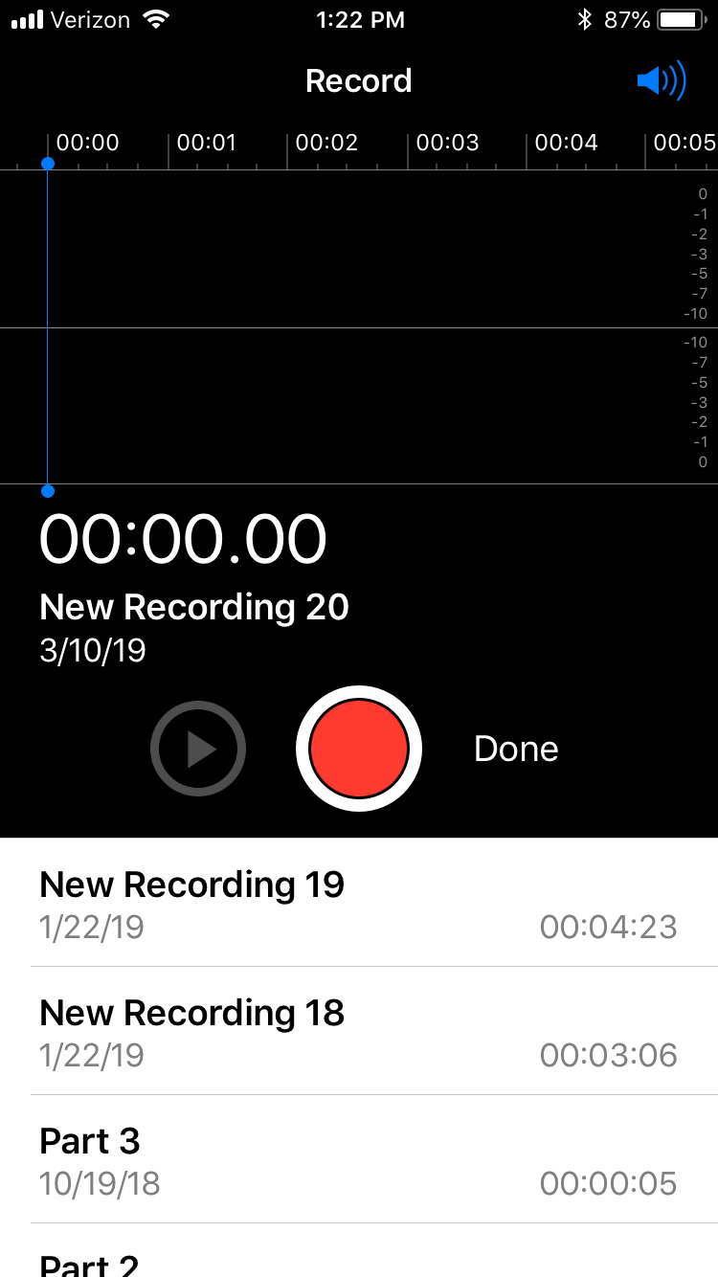

2. Place phone on a solid surface free from outside noise and begin recording.
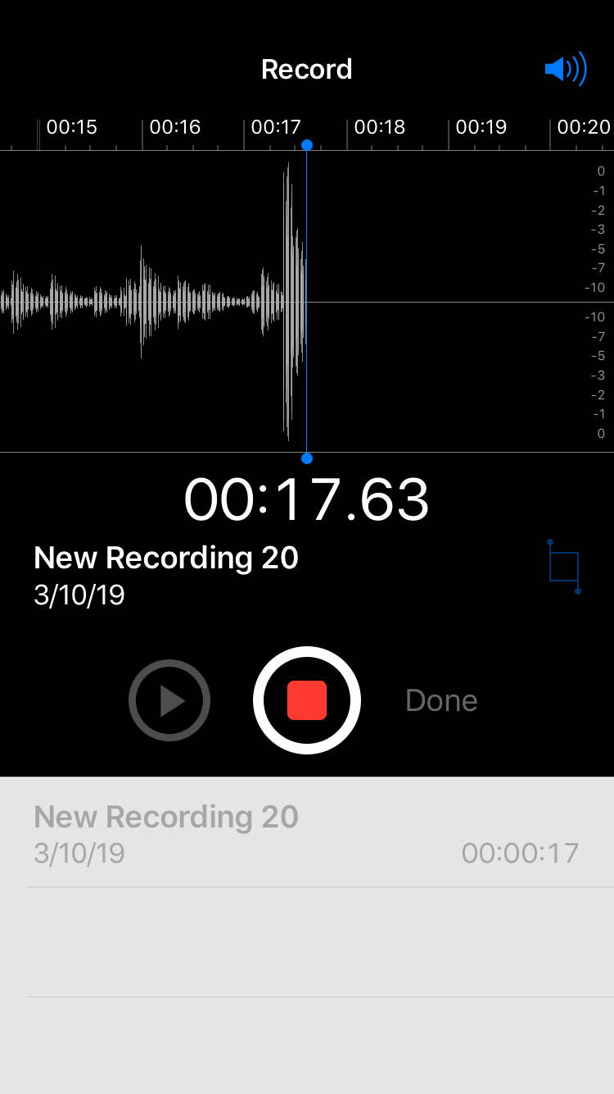
3. Save recording under a name.
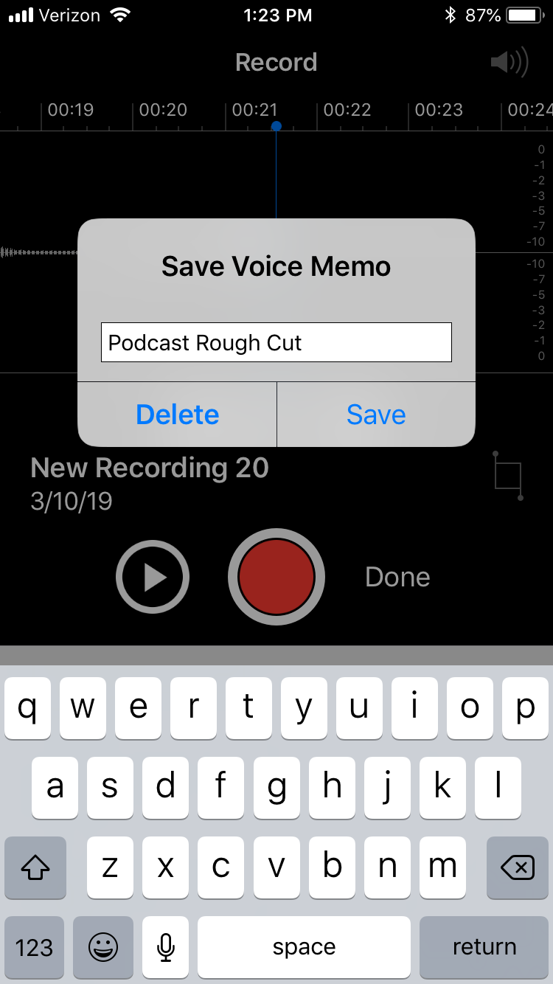
.
4. Send or save audio file on your computer or through a DropBox folder. (You can also plug your phone in a computer to save audio file.)

