TARES Test: What is it and how can it help with decision-making?

READ:

- TARES Test (Media Ethics Issues and Cases, 9th edition)
  - What is it? How do you use it?

ACTIVITY:

- Have students work in small groups of three to determine whether the advertisement (attached below) would pass the TARES Test.

Example:

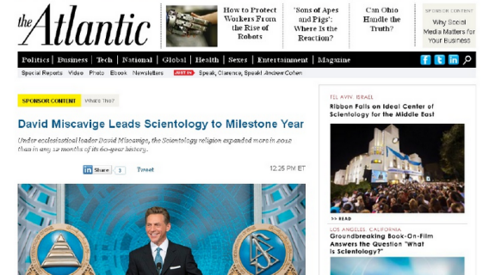

- Students should use the chart below to help formulate their thoughts and submit their responses. A handout will be provided to students.
  - Once completed, students and the adviser will discuss the findings with an in-depth look into how The Atlantic handled the case following complaints.
    - On the Atlantic's Scientology Ad (and Aftermath)
    - The Atlantic publishes then pulls sponsored content from Church of Scientology

Is it TRUTHFUL?
Is it AUTHENTIC?
Is it RESPECTFUL? (Is it misleading or deceptive when it reaches the consumer/reader?)
Is it EQUITABLE? (Is there an equal field between the advertiser and the consumer?)
Is it SOCIALLY RESPONSIBLE?

