Camera Basics
FOCUS: Adjusting the focus on your camera allows you to control the clarity of a photo, and in some cases allows you to “focus” on a subject while leaving the remaining portion of the image “blurred.”

ISO: adjusting the ISO on your camera impacts the camera’s sensitivity to light. The slower the ISO, the less sensitive it is to light. Using slower ISO may be more suitable outdoors during a sunny day.

APERTURE: Adjusting the aperture on a camera affects how much light you let into your camera to capture an image. The wider the aperture, the more light is allowed in. This feature can be used to create depth of field in photos.

SHUTTER SPEEDS: Adjusting your shutter speed determines how long your camera’s shutter remains open. The longer your shutter speed remains open, the more light you will add to your photos.

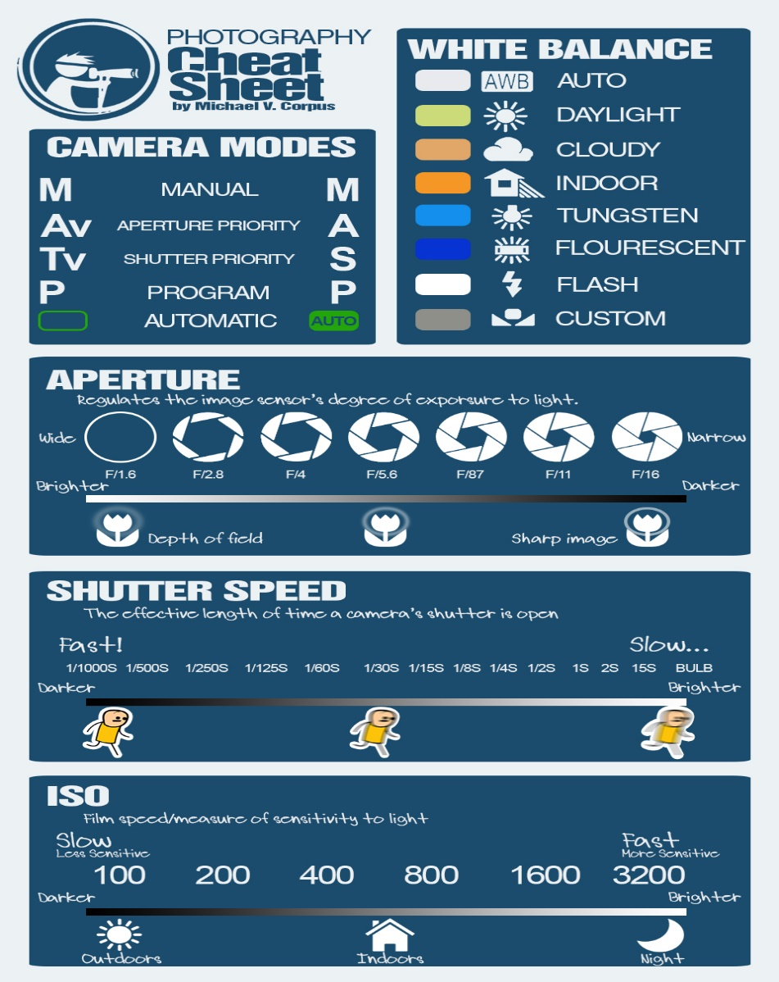
Courtesy: https://mikeroscoop.wordpress.com/2014/09/22/dslr-cheat-sheet-that-fits-perfectly-in-a-smartphone-screen/

