Media Ethics Example
CASE #2:
- LOOK: Walmart Gun Display Photo
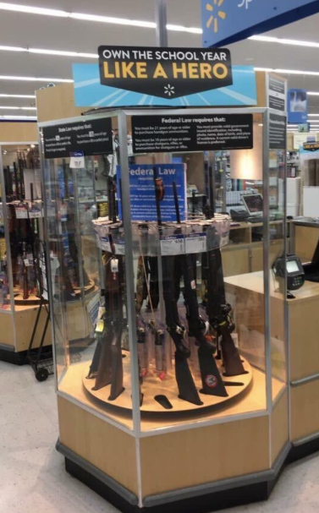

ACTIVITY: What do you do?
  - You come across this photo on Facebook. How do you approach this as a journalist?
    - What questions do you ask?
      - Write a list of questions that you would need to write a report.
      - Is this photo real? How would you determine its authenticity?
  - READ: Walmart apologizes for 'Own the school year' gun display
    - Did the report follow your line of questions?
    - Are there any questions you would ask?
    - Would you follow-up on the photo’s origin?
  - READ: Walmart says viral photo of gun display touting 'own the school year like a hero' was staged
    - What did you learn?
    - Why is it important to follow-up on this story? Does it deserve the same attention? Why or why not?
    - Describe your ethical reasoning in reporting on the follow-up. Why is it important?
  - REACTION:
    - It Is crucial to develop a habit of following-up on your stories as information can change based on time and new developments. In this case, Walmart received a lot of negative attention after the photo released showed a back-to-school sign placed above a gun display. In the initial reports, it was unclear whether a Walmart employee had set-up the display. But after learning that Walmart’s investigation revealed it was staged, it’s crucial to report the findings to the audience to maintain ethical integrity and provide a fair and balanced reporting.

