CASE #7:
Greenland Melting
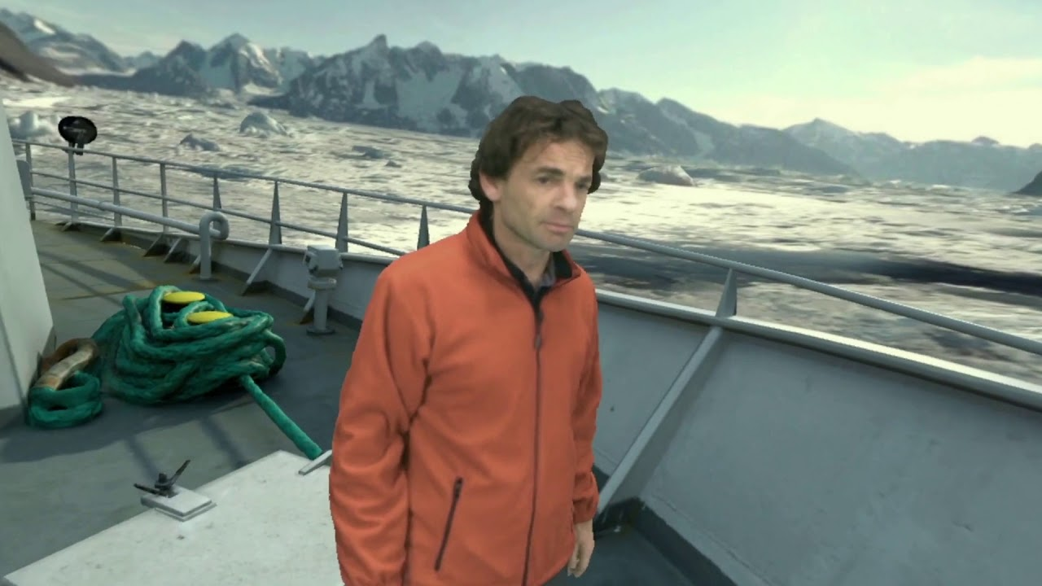
Summary: PBS’ Frontline worked with a virtual reality team to build a story on the Greenland Ice Cap. Scientist Eric Rignot is featured in the 360-degree experience as a narrator. As detailed in an article written by Angelo Paura, it’s noted that the creators of the story were faced with the ethical dilemma of what type of clothes the narrator should wear as he narrated the piece. The author notes that while it may seem “trivial,” the discussion over whether it would deceive viewers was brought into question.
ACTIVITY: What do you think?
- What are your thoughts on applying ethical standards to new media?
  - Why is it important to analyze how we are piecing together our stories for public consumption?
    - What are good questions to ask yourself when determining how you are presenting your story?
REACTION:
- No matter the medium, ethical standards should remain the same. In the case of virtual reality, it’s imperative to develop a system where you ask yourself how the presentation of facts could be disinterested or misleading to the viewers. While the ethical standards remain the same, evolving technology requires a deeper look into how we share our stories. It’s critical to also remain transparent and communicate with readers/viewers on recreated or added material.

