ELEMENTS OF A GOOD PHOTO
Composition
- Composition matters. It helps to create diversity, uniqueness and creativity to your photos.

LIGHTING
- Just like composition, lighting matters. Using different lighting techniques can change the way your photo looks and the story it shares with readers.

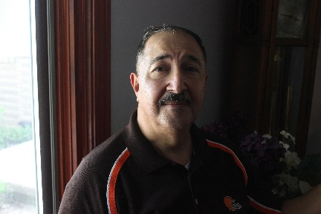

SHOOTING EVENTS
TIPS:
- Be prepared
  - If you know you’re going to shooting outside, analyze the possible lighting situations you’ll be in or what you’ll need. Do you know where you’ll be going?
- Request credentials, permission for private events
  - Not requesting the proper credentials or permission can leave you and your camera in the dark on event day.
- Make sure to ask for the names of the people in your photos. It’s good to ask permission and for the correct spelling of the names.
- Tell a story
  - Shoot your photos as if you’re telling a story. Could a viewer understand the story by simply looking at your photos and captions?
SHOOTING SPORTING EVENTS
TIPS:
- Be prepared
  - Be prepared for the unexpected. You won’t be able to plan your shots, but you can be prepared for what might happen. Use the continuous mode on your camera to help you capture action shots.
- Getting the right lens:
  - If you know you’ll be shooting from far away, make sure you have a long lens to capture the action.
- Action vs. Reaction
  - While you may be waiting for the action, capturing the reaction could be just an impactful – if not more. Capturing a reaction can help tell a story of triumph or loss. Be sure to keep your camera close after winning shot.

PORTRAITS
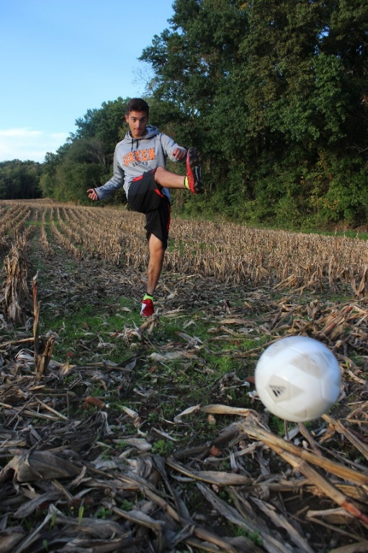
TELLING A STORY
Taking photos of individuals can seem straight forward. But there’s more to a photo of someone than just a “mug shot.” Portraits can tell a story.
TIPS:
- Use your surroundings to help tell the story. What are you trying to capture? Are they an athlete? Ask your subject to show you something they can do. Capture their body language through their actions or their emotion.
- What’s the story? Develop an understanding of your subject and what they’re trying to say. If there’s a place that stands out to them, have them take you there and share stories. Capture the walk-and-talk as opposed to having them stand in front of something looking directly at the camera.

