AD | PRICE | VISUAL EXAMPLE
Rotating Ad (200 by 300 pixels)  - These ads rotate each day on the web site. | $30 per month  $240 per year | 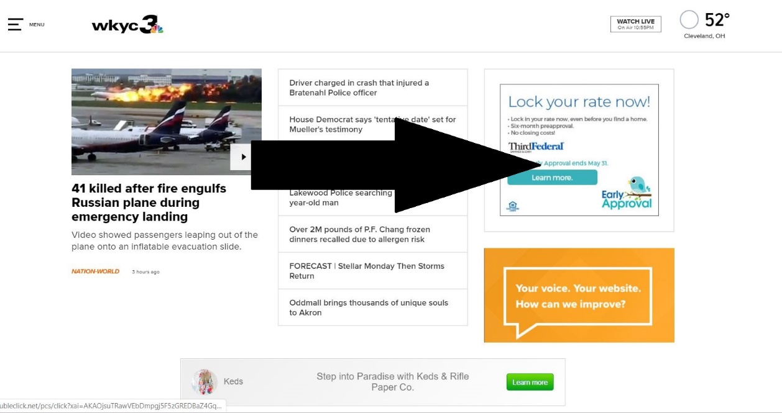
Fixed Ad  - These ads stay on the web page for the entire duration of the monthly contract. | $60 per month  $480 per year | See photo above.
Banner Ad | $25 per month  $200 per year | 