https://www.lynda.com/Photography-tutorials/What-exposure/734659/801226-4.html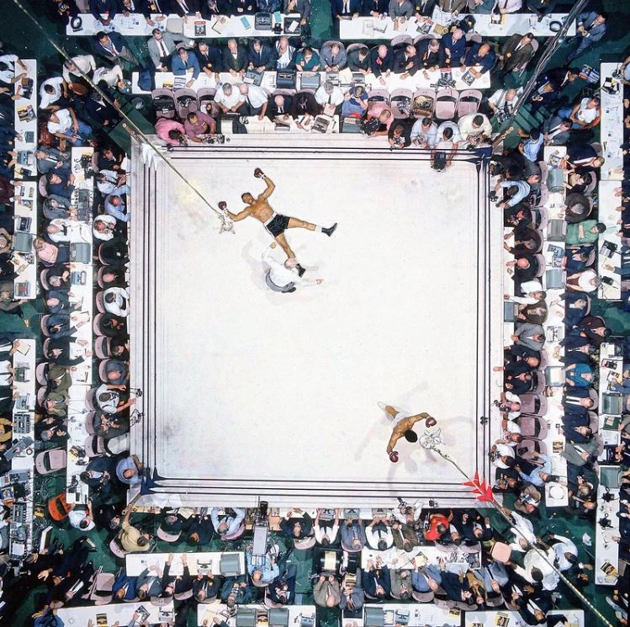

MUHAMMAD ALI AND CLEVELAND WILLIAMS
Nov. 14, 1966 | Ali knocks out Cleveland 'Big Cat' Williams in three rounds at the Houston Astrodome to defend his heavyweight title in November 1966. The bout drew a record indoor crowd of 35,460.

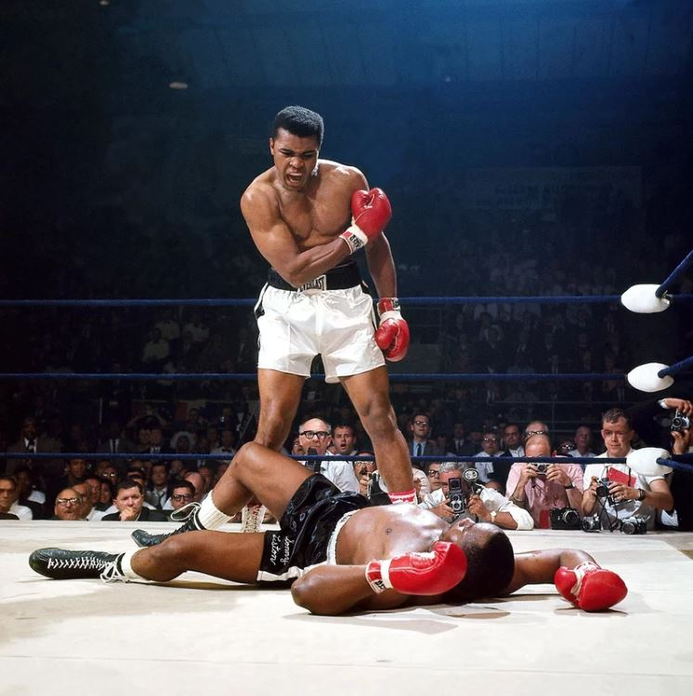

MUHAMMAD ALI AND SONNY LISTON
May 25, 1965 | In their heavyweight title rematch Ali defeated Liston by knockout in the first round. Ali would hold the heavyweight title until 1967, when he was stripped of it for refusing to be drafted into the Army.

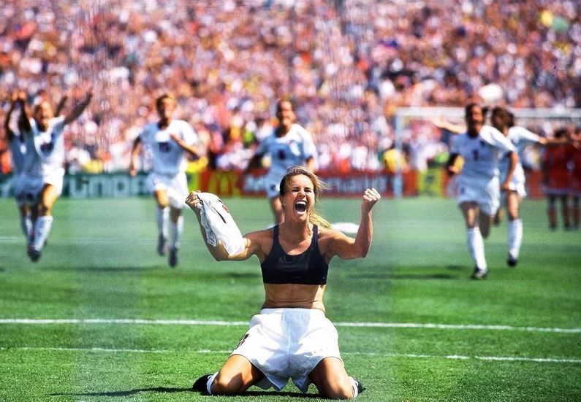

BRANDI CHASTAIN
Women's World Cup, July 10, 1999 | U.S. women's soccer player Brandi Chastain exults after kicking the World Cup-winning penalty kick in the 1999 Women's World Cup final.

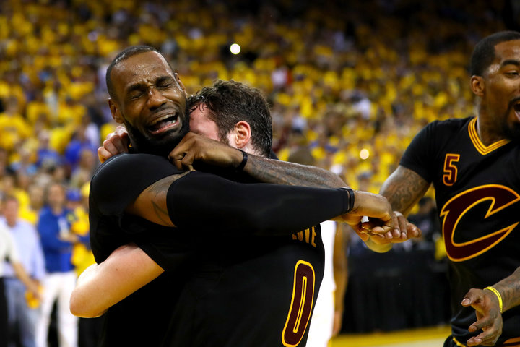

LeBron James
June 19, 2016 | LeBron James hugs his teammate, Kevin Love, following the Cleveland Cavaliers 2016 championship win against the Golden State Warriors.

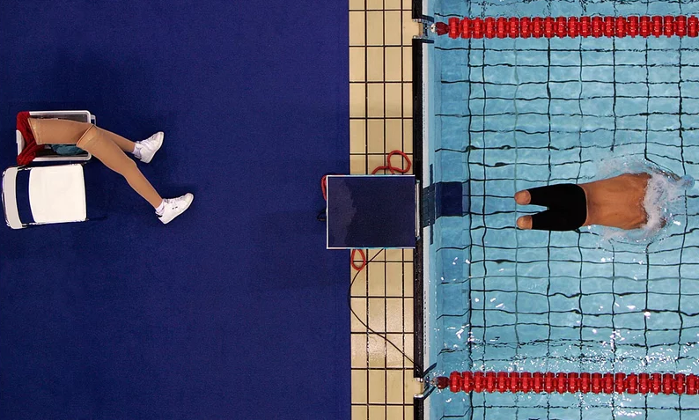

JAVIER TORRES
Paralympic Games, Sept. 21, 2004 | Spain swimmer Vicente Javier Torres starts the 150-meter individual medley at the Paralympic Games. Torres took the silver medal in the race.

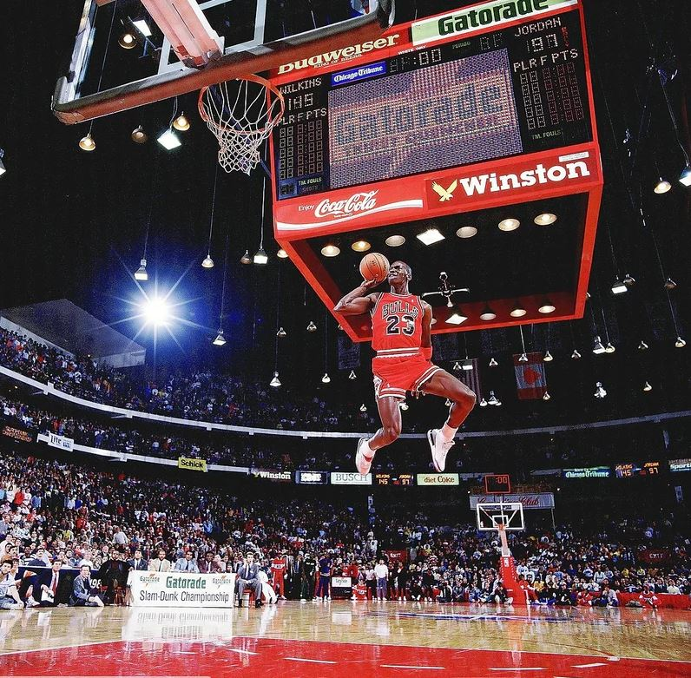

MICHAEL JORDAN
All-Star Weekend, Feb. 6, 1988 | Air Jordan takes off from the free throw line and soars to a perfect score of 50 to defeat Dominique Wilkins in the finals of the Slam Dunk Contest. It was the second straight title for the Bulls star, and the '88 contest is widely considered the best ever because of the duel between Jordan and Wilkins

