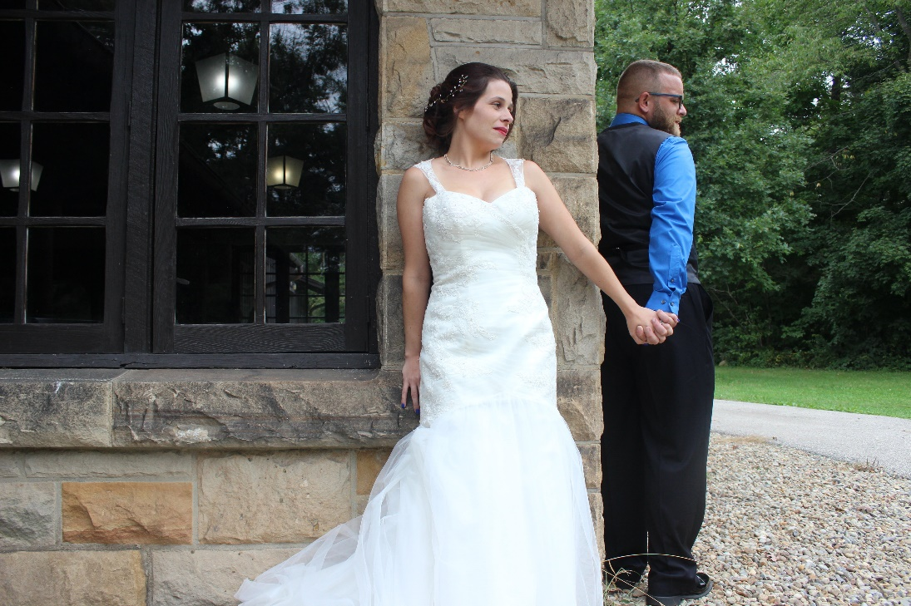
Bride whispers "I love you" to her husband as they share a moment of surprise before celebrating.
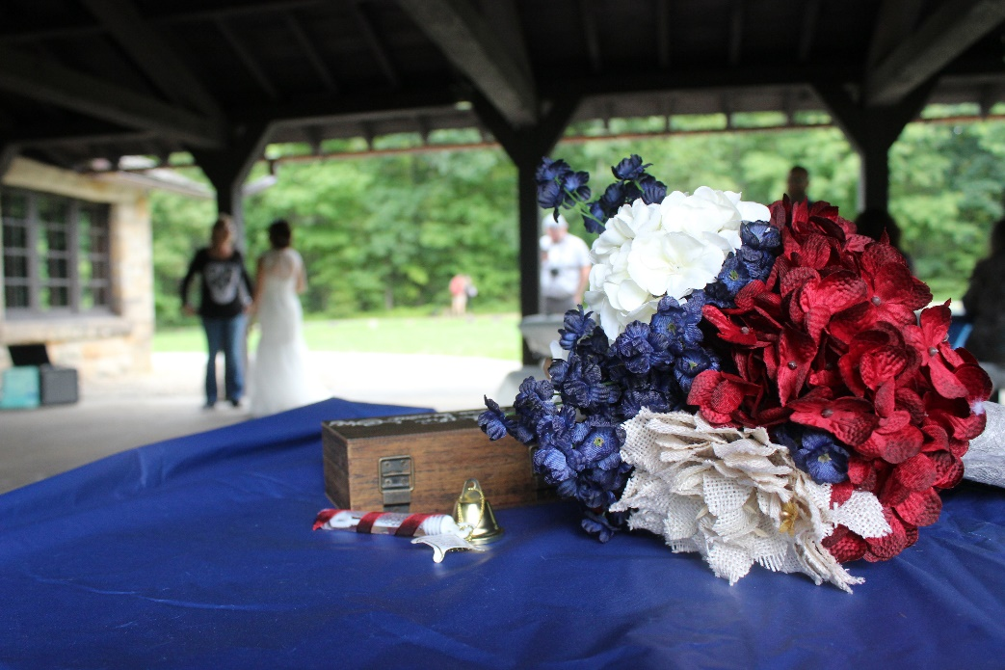
The bride mingles with guests in the background as her bouquet is set aside for the reception.
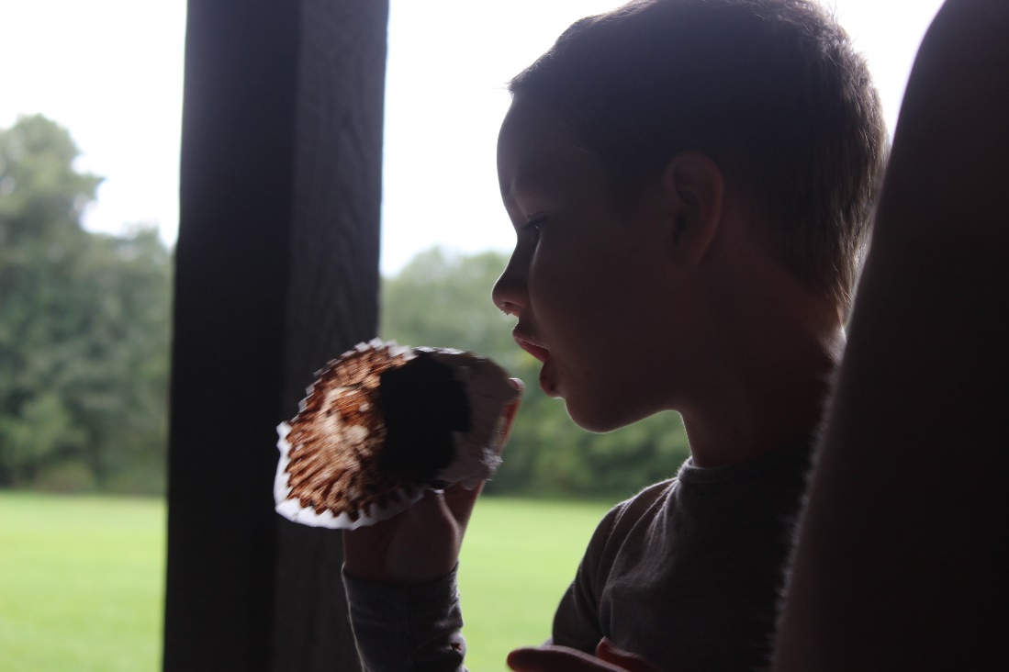
A young boy enjoys a wedding cupcake.
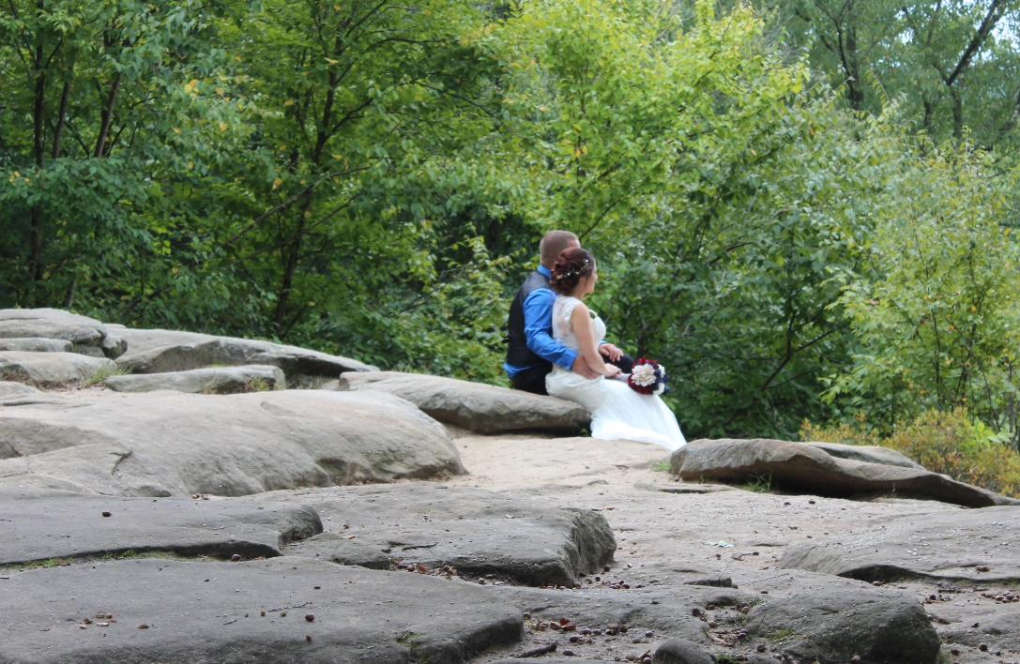
The newly married couple spends some time together along the "Ledges" at the Cuyahoga Valley National Park.
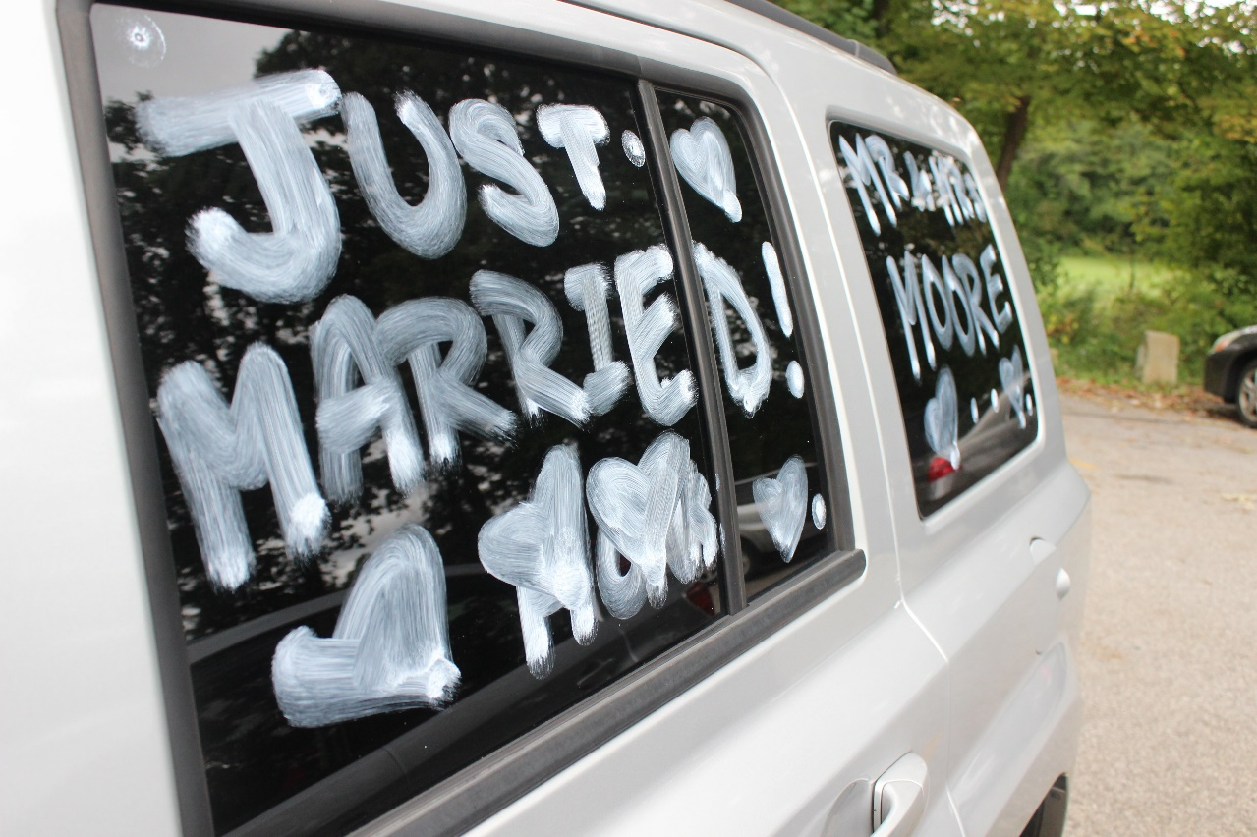
The couple's car shares the celebrated message of their marriage.
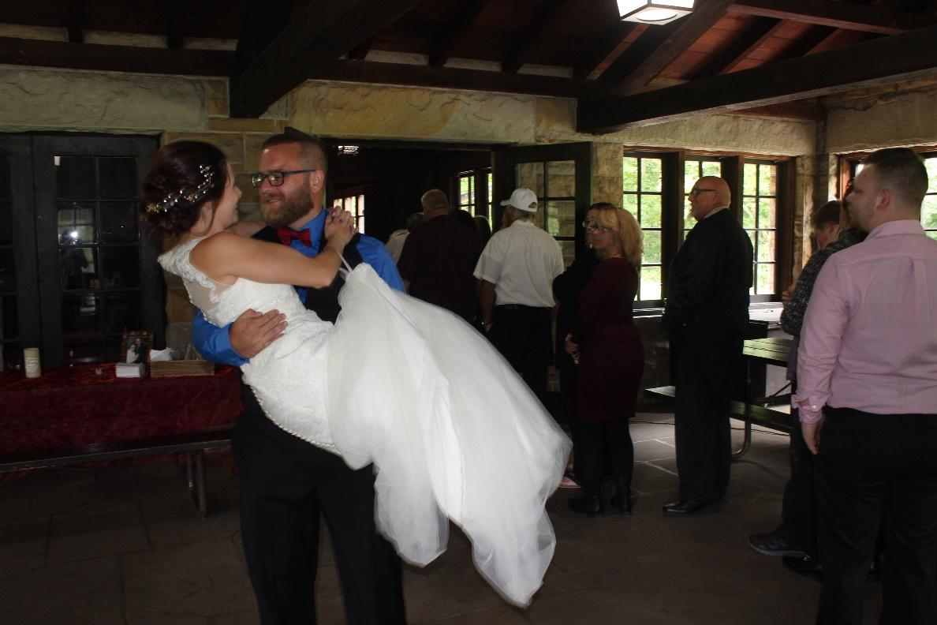
The groom picks up his bride before beginning the reception celebration.

