LESSON: Building good communication is key for healthy relationships, including the communication between administrators and student journalists. But what happens when an administrator questions the loyalty of a student and the school. What should journalists do when they are questioned about their coverage, specifically when an administrator thinks the student should be publishing positive press.
READ/ANALYZE:
- PRSA Code of Ethics
- SPJ Code of Ethics
ACTIVITY:
- In groups of two, students will read the PRSA Code of Ethics and SPJ Code of Ethics to determine similarities and differences. Students will be given two handouts and will identify what portions are similar and what areas make PR and Journalism different.
  - Students can mark on the handout as seen below in the answer/example key.
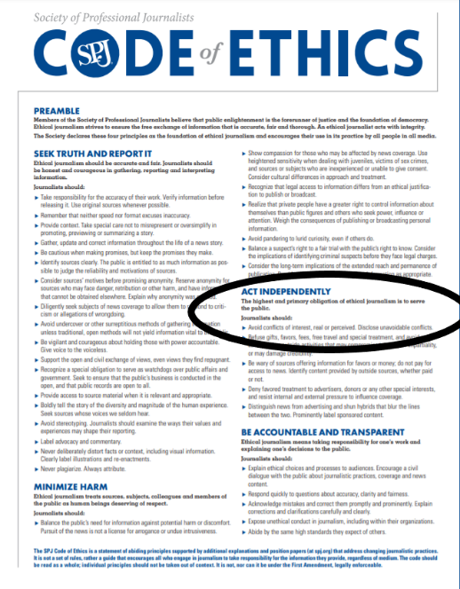
NOTE: Above shows the difference in journalism and public relations based on who each serve during communication. For journalists, serving the public is the priority. For public relations professionals, serving their client is priority.
- Once students have idenitifed differences and similarities between the two, students will work independently to write a summary on the key points they’ve identified in their search. Students should answer the following questions:
  - What do you think is the key difference in the role of public relations professionals and journalists?
    - Who do each serve in their roles?
    - How does their communication to the public differ?
    - What ethical similarities do they share?
ACTIVITY:
READ: Journalism ethics do not apply to public relations
- Students will be presented with the following case and will be instructed to determine how they would respond. Students should use the previous activity to help construct a response.
CASE: You have written a story related to discrimination with the school’s athletic department. The principal and superintendent have requested a meeting with you before publication. They note that you are a student and should be publishing a positive piece on the school. They say the publication should support the school and serve students and staff. How do you respond to the situation?
- Students should write their response by including supporting evidence from the SPJ and PRSA code of ethics. Students should cite at least three pieces of material that support an argument that student journalists are not public relations officials.

