Lesson Summary:
The purpose of this lesson is to gain an understanding on the importance, creation and use of cutlines in journalism. Students will explore the role cutlines play in enhancing an article to help tell a story. Students will experiment with creating cutlines for several photos.
Estimated Duration:
This lesson will be taught over the course of two 60-minute sessions.
Instructional Procedures:
Day 1: (60 mins)
- What is a cutline?
  - IJNET: Tip for writing captions
  - Killer Cutlines (Wayne Dunn)
    - What does a cutline provide to a story?
    - What is its importance?
    - What does it include?
  - VIDEO National Geographic advice on approaching cutlines/captions
  - Students will be presented will three examples of cutlines attached to this lesson.
- Group Activity: (20 min)
  - Students will be presented with a photo (attached below) and will work in groups to determine a cutline. If challenges are presented, students should describe the obstacles in reaching a description for the photo.
    - Did you have enough information to come up with a cutline?
    - What are you missing?
    - Students will be given original cutline (below) following the discussion.
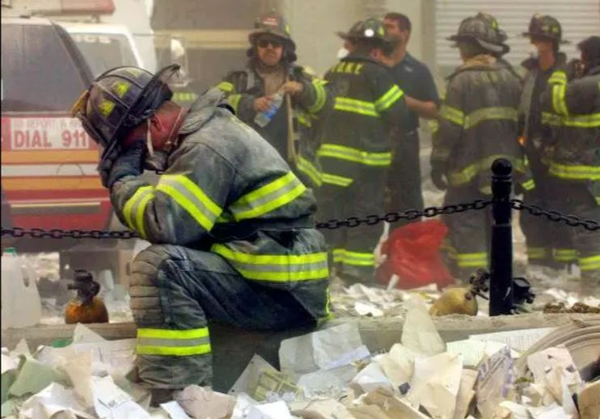
NEW YORK - SEPTEMBER 11, 2001: (SEPTEMBER 11 RETROSPECTIVE) A firefighter breaks down after the World Trade Center buildings collapsed September 11, 2001 after two hijacked airplanes slammed into the twin towers in a terrorist attack. (Photo by Mario Tama/Getty Images)
- HOMEWORK:
  - Read: https://nie.washingtonpost.com/sites/default/files/Good%20Picture.pdf
Day 2: (60 min)
- GROUP PROJECT:
  - Students will work in pairs to pick two photos they have captured during the school year to write a cutline for each. Each of the cutlines for the photos should include the following:
    - Identifies the subject in the photo.
    - Identifies the location and when the photo was taken.
    - Provides context to the photo.
    - Cutline is brief. (One or two sentences)
    - Includes photographer’s name and publication
Homework Options and Home Connections
- Students will complete the assigned reading and the group project assigned in day 2.
Materials and Resources:
- Access online
Attachments
- Students will be provided with the example photos attached to the lesson.
Assessment:
- Students will be assessed based on their classroom participation (15 points) and cutline group project (25 points). TOTAL: 40 points
Scoring Guidelines:
- Please see attached rubric.

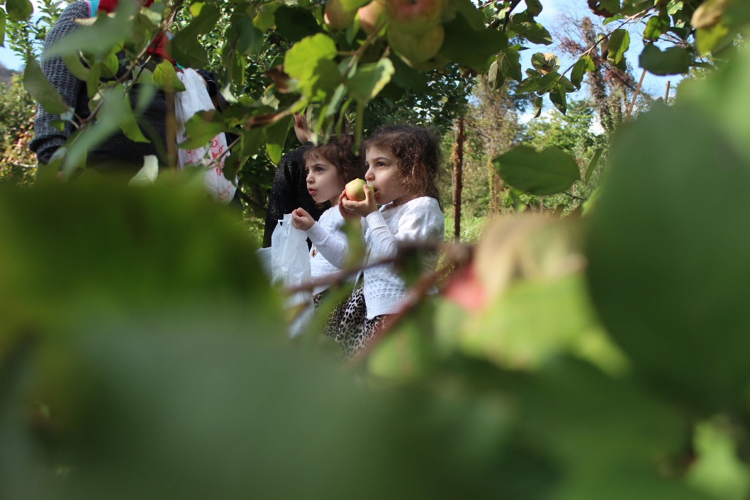
Twins Aleena (left) and Amelia Abraham, 2, enjoy a pair of fresh apples picked at﻿ Great Country Farms in Bluemont, VA as hundreds welcomed the fall season at the farm on Saturday, Oct. 20, 2018.
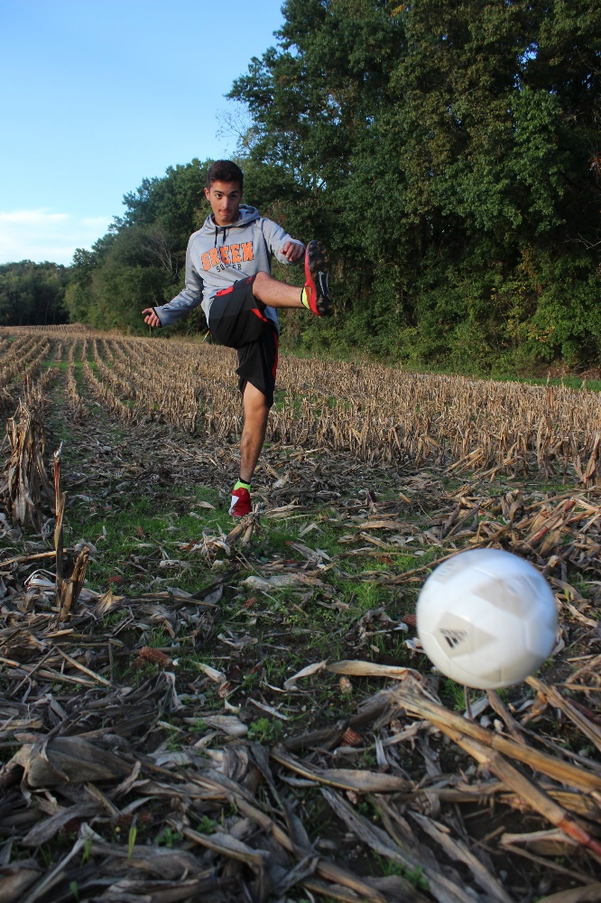
Layth Hammoudeh, 14, kicks a soccer ball in a cornfield near his home on Oct. 14, 2018 as he prepares for his first season on the junior varsity soccer team at Green High School. Hammoudeh will be among other student athletes competing for a spot on the varsity team this year.
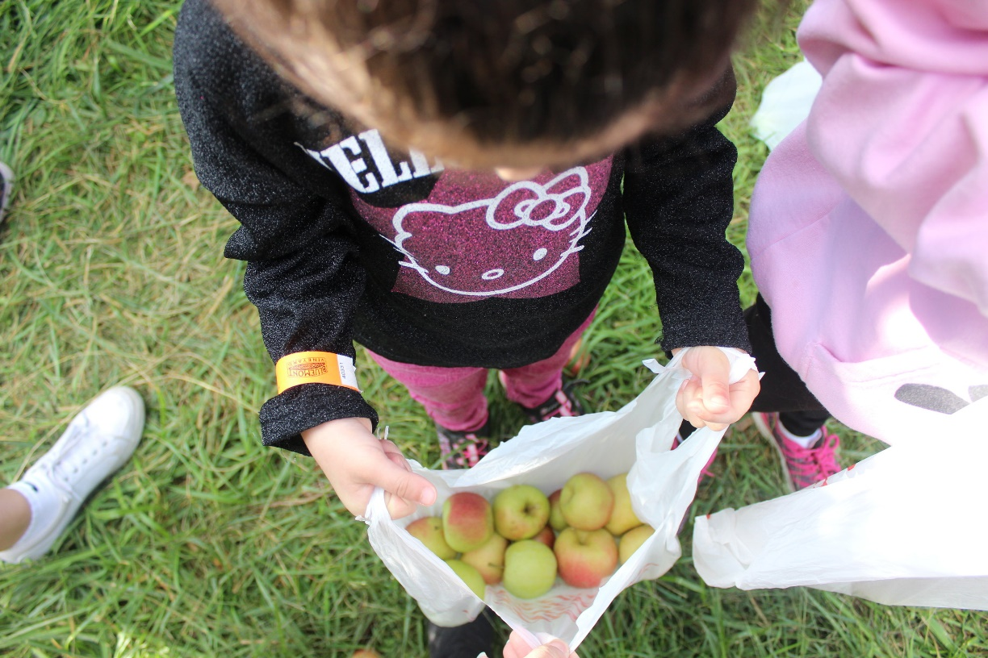
Sophia Abraham, 4, counts the apples she picked during a family outing at Great Country Farms in Bluemont, VA on Oct. 20, 2018. The apples, along with sunflowers at a field nearby, will be available for picking through the month of October.

