Lesson Summary:
The purpose of this lesson is to understand and experiment with the use of environmental photos and its purpose within the walls of storytelling. This lesson will focus on how to use your “environment” and storytelling techniques to capture a unique portrait.
Estimated Duration:
This lesson will be taught over the course of two sessions, 60 minutes each.
Instructional Procedures:
Day 1: (60 mins)
  - The class session will begin a look at the first two sections of the “Narrative Portraiture: Foundations of Portraiture” lesson on Lynda.com.
    - “Looking at Portraiture” (20 minutes)
      - What makes a good portrait? Feeling? Does it relate to a single person or can it also relate to a group?
      - What “feeling” or emotion are you trying to showcase in the photo? What’s the story behind the picture?
    - “Stories and Subjects” (40 minutes)
      - How can a photographer make his subject feel more comfortable? Talking? What kind of questions would you ask? How can you express enthusiasm for their background/passion?
      - What is the story? How do you tell it through a portrait? Location? Action?
  - HOMEWORK: Read and review King's presentation on environmental portraits titled “People: Capturing their Spirits.”
Day 2: (60 min)
- Analyzing a pair of environmental and group photos: (20 min)
  - Group discussion based on the two photos attached to the lesson plan.
  - What does it capture? What do the photos tell you? Could you write a story surrounding the picture? What would you have done differently?
  - How do you incorporate more than one individual in a photo?
- Students will be assigned a partner to take each other’s portrait. The portraits will be taken outside of the classroom (deadline will be a week from when the project is assigned). (40 min)
  - Get to know your partner:
    - Find out something you didn’t know about your partner.
    - Ask a series of questions to get to know your partner.
    - Determine what type of environmental photo you might want to capture of your partner? How would you try to capture an environmental photo?
    - What do you think it would look like if you were writing a story based on what your partner told you?
- Over the next week, experiment and capture at least one environmental portrait of your partner and a group photo involving your partner. Along with the two photos, submit a 150-300 word summary of you experience.
  - Did it turn out how you expected?
  - What did you like about the portrait?
  - Did it capture the story you wanted to share?
  - What changed from your original vision?
  - What might have you don’t differently?
Homework Options and Home Connections
- Students will submit their final environmental and group portraits along with the summary of their experience, answering the questions above. The assignment will be due one week after it is assigned.
Materials and Resources:
- DSLR
- Access to Lynda.com
- Access online
Attachments
- Students will be provided with the following two photos for group discussion. 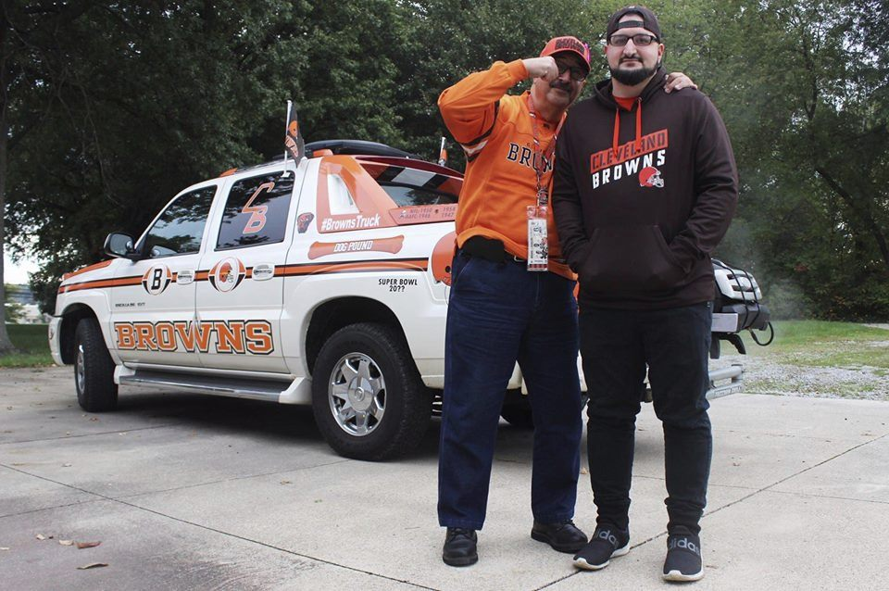
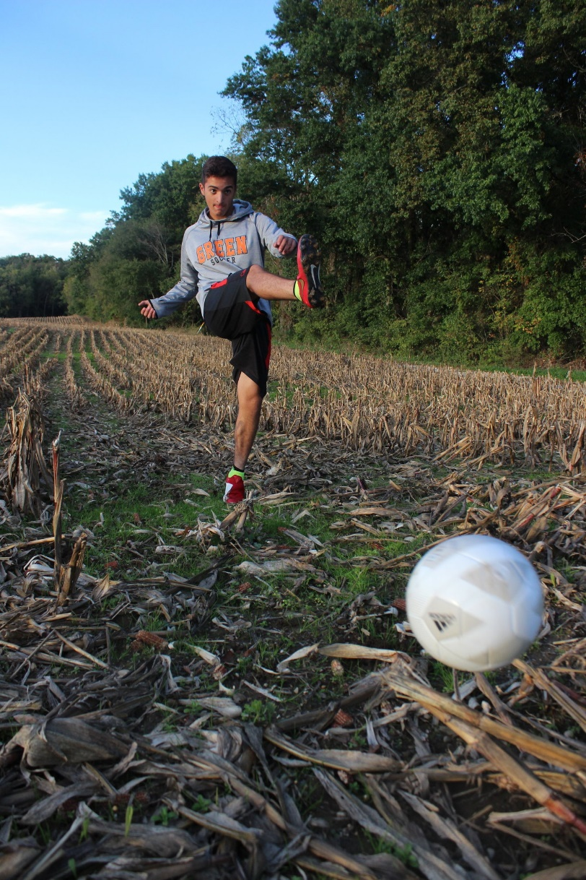
Assessment:
- Students will be assessed based on their classroom participation (15 points) and final environmental photo assignment (25 points). TOTAL: 40 points
Scoring Guidelines:
- Please see attached rubric.

