Lesson Summary:
The purpose of this lesson is to gain an understanding and develop techniques related to handling a camera. Students will learn the basic tips on how to care for and handle a camera to add stability to shots and to protect equipment.
Estimated Duration:
This lesson will be taught over the course of one 60-minute session.
Instructional Procedures:
Day 1: (60 mins)
- Group Activity: (15 min)
  - Take a look at each photo (2) and address any concerns you may have with how the individual is handling their camera? Would you give this person any tips or guidance? Why or why not? HINT: How can you help protect the camera and provide stability?
  - 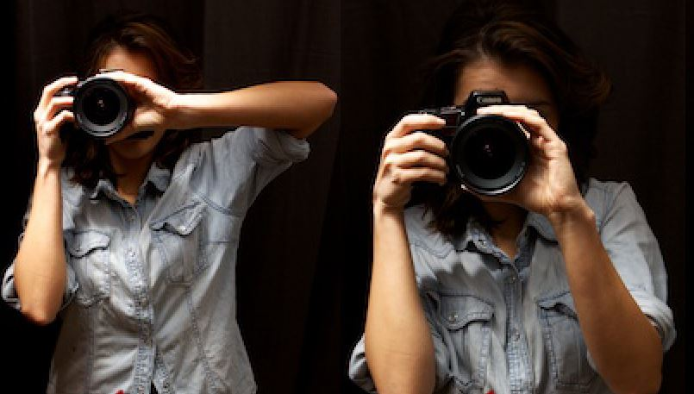

- Instruction: (35 min)
  - Watch “How to properly hold your camera.”
    - NOTES: stability, anchoring
  - Watch “How to handle your camera.”
    - NOTES: anchoring, camera straps, lens protection
  - Read: “How to Hold a Camera and Take Sharper Photos”
    - NOTES: stability (pictures provided), reference group activity.
  - Caring for your lens: “How to Clean your Lens and Filters”
    - NOTES: using filters, refrain from touching your lens, using cleaning solutions

- Evaluation:
  - Complete the evaluation/assignment attached to this lesson.
    - DUE: Next class session
Homework Options and Home Connections
- Students will complete their evaluation assignment.
Materials and Resources:
- DSLR
- Access to Lynda.com
- Access online
  - https://www.quora.com/What-are-some-best-practices-for-holding-a-DSLR-camera-correctly
  - https://www.youtube.com/watch?v=tV003VTNmgs
  - https://expertphotography.com/how-to-hold-a-camera/
  - https://www.bhphotovideo.com/explora/photography/tips-and-solutions/how-clean-your-lens-and-filters
Attachments
- Students will be provided a handout with camera handling tips. The handout is courtesy of “Digital Camera World.”
Assessment:
- Students will be assessed based on their classroom participation (15 points) and final evaluation assignment (35 points). TOTAL: 50 points
Scoring Guidelines:
- Please see attached rubric.

