Lesson Title: Responding to Information as a Journalist

Description of the lesson: So you have all the information for your story. Or – so you think. As journalists, it’s our job to question and remain skeptical when it comes to information we receive from our subjects and sources in stories. The importance of this not only translates to creating an environment filled with verified information, but to also focus on the context of how the information fits into the story.

A passive journalist allows for information to get through to readers/viewers due to an inaccurate process of verification and being a skeptical journalist. In an era where television networks stream around the clock, the challenge comes with structure and asking questions to verify information or provide evidence to their guest’s arguments. If you’re not asking for evidence, can your subject or source say anything he/she wants?

Objectives

by the end of this lessons, students will be able to ..

- Understand the importance of fact-checking and verifying information from sources.
- Identify steps to take in an interview to facilitate a discussion.

Before moving forward, read:
- Blur, Chapter 7
- SPJ Code of Ethics: https://www.spj.org/ethicscode.asp
- Accuracy in our reporting: http://ethics.npr.org/category/a1-accuracy/

Procedures:

ACTIVITY 1
- Take a look at the press release below. You can find the full text from the press release attached to this lesson.
  - The information was posted on http://www.genewscenters.com/ following a New York Times article that was published stating that GE had not paid taxes despite its large profits.

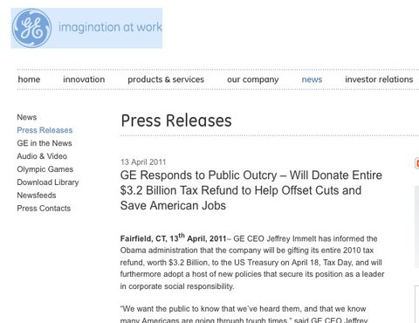
- Identify how you would approach coming across this information while at a news desk.
  - Detail in steps how you would begin to report the story.
    - HINT:
      - Where is the information coming from?
      - Why has this information been released?
      - What’s the tone of the press release?
      - Can you verify information on the press release?
  - Write a brief summary on your conclusion on whether to report this information or confirm through additional sources.

ACTIVITY 2
- You are a talk show host who will be interviewing (live) a gun rights activist ahead of planned protests across the country. How would you facilitate the discussion to steer away from passive journalism?
  - Would this include research?
  - How do you handle numbers and information presented during the interview?
    - What happens if you’re unable to fact-check immediately?
    - How can you be transparent with listeners/viewers?
  - How do you present the other side of the argument in order to open dialogue?

GE PRESS RELEASE:

Fairfield, CT, 13th April, 2011- GE CEO Jeffrey Immelt has informed the Obama administration that the company will be gifting its entire 2010 tax refund, worth $3.2 Billion, to the US Treasury on April 18, Tax Day, and will furthermore adopt a host of new policies that secure its position as a leader in corporate social responsibility.

"We want the public to know that we've heard them, and that we know many Americans are going through tough times," said GE CEO Jeffrey Immelt. "GE will therefore give our 2010 tax refund back to the public and allow the public to decide how to spend it."

Immelt acknowledged no wrongdoing. "All seven of our foreign tax havens are entirely legal," Immelt noted. "But Americans have made it clear that they deplore laws that enable tax avoidance. While we owe it to our shareholders to use every legal loophole to maximize returns - we also owe something to the American people. We didn't write the laws that let us legally avoid paying taxes. Congress did. But we benefit from those laws, and now we'd like to share those benefits. We are proud to be giving something back to America, and we are proud to set an example for all industry to follow."

Over the coming weeks, GE will conduct a nationwide survey to determine how the company's $3.2 billion returned refund is to be allocated. The survey will be conducted both online and offline, and will permit the public to weigh in on which of the recently-enacted budget cuts they would like to see reversed.

In tandem with the gift, the company is also announcing a host of new policies to restore public faith in the GE brand, including a commitment to keep American jobs in America, and to create one U.S. job for each new job created abroad. The ambitious plan will overhaul accounting systems to allow public transparency and phase out the use of tax havens in five years. "Given my recent appointment as President Obama's Chairman of the Council on Jobs and Competitiveness, it is no longer appropriate for GE to engage in practices that, whether by fact or perception, are at odds with the greater good of the nation," Immelt said.

Immelt outlined several concrete steps he would take to push for modernized tax policies that reflect the realities of the global economy. "I will personally ask President Obama to work with Congress to require country-by-country reporting by multi-national corporations of the sales made, profits earned and taxes paid in every jurisdiction where an entity operates. Instead of moving money via "transfer pricing," corporations ought to pay taxes in the jurisdictions where profits are actually made. If Congress is able to establish standard industry-wide solutions, GE will close our tax haven operations abroad, including our subsidiaries in Bermuda, Singapore and Luxembourg."

Further details on GE's new policy will be released in the coming weeks.

About GE
GE (NYSE: GE) is an advanced technology, services and finance company taking on the world's toughest challenges. Dedicated to innovation in energy, health, transportation and infrastructure, GE operates in more than 100 countries and employs about 300,000 people worldwide. For more information, visit the company's Web site at www.ge.com.

PRESS CONTACTS
Samuel Winnacker
GE Corporate, Assistant Director
Communications & Public Affairs
+1 615 375 6658
samuel.winnacker@ge.com

