Photo Management/Archiving Photos

Save photos in the designated folders as requested by your adviser. Each photo should be uploaded with the corresponding metadata, including cutlines, photographer’s name and date.

Follow the steps below in Photoshop to add the correct metadata to your photos for easy retrieval.

Step 1:

Upload your photo into Photoshop. Go to your File menu and click on “File Info.”

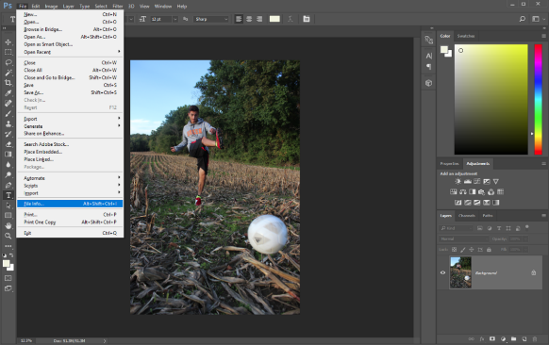

Step 2:
‘
You will find a blank elements for your photo’s information including title and description (cutline). Make sure to include a written confirmation of when your photo was taken.

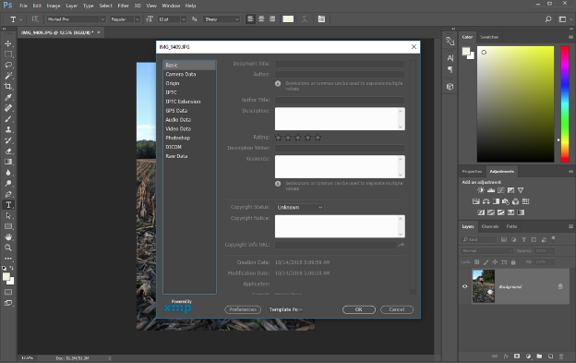

Step 3:

Begin to write down the information for your photo. Please include the title, author, description and keywords. Once completed, click “OK” and save the photo in the designated folder.
:
