Volume
1
Student Media
Photojournalist Staff Manual
The power of an image.
Photojournalist staff manual

Guide

Table of Contents
Staff Hierarchy and collaboration 1-2
What are your rights as a photojournalist?.......................... 3
What are your responsibilities as a photojournalist? 4
Code of Ethics 5
Making Ethical Decisions 6
Camera Basics 7
Elements of a Good Photo 8-11
Lighting 12-13
Shooting Events/Sporting Events 14
Portraits 15
Camera Handling 16
Photo Editing/Cutlines 17
Archiving Photos 18-20
STAFF Hierarchy/Collaboration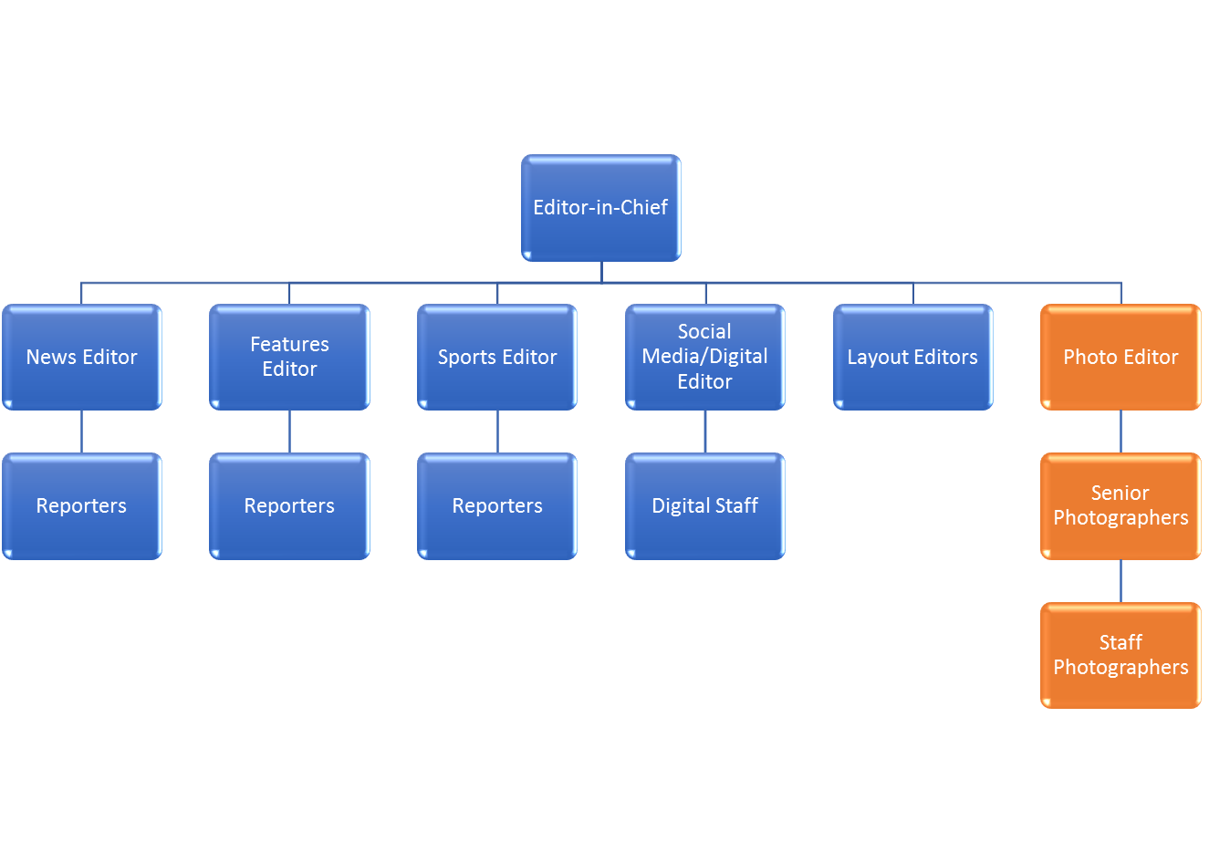
Adviser
Photo Editor | The photo editor(s) is responsible for assigning and reviewing images for publication. Responsibilities include mentoring senior and staff photographers and helping to reinforce ethical and responsible photo journalism. The photo editor is responsible for reviewing photo, edits made and the final cutline that will be used in publication.
Senior Photographers | Senior photographers carry the responsibilities of staff photographers which include completing assignments, edits and cutlines, but also help to guide, mentor and help with assignments given to staff photographers.
Staff Photographers | Staff photographers are required to complete assignments as requested through the guidance of senior photographers and photo editor(s). Photographers are responsible for capturing photo, editing and writing cutlines. Final edits and approval are made by photo editor(s).

What are your rights as a photojournalist?
Where can you capture photos at a university?
Public | Private
Outdoor Locations (visible to public foot traffic)  - Sidewalk  - Parking Lot  - Sport Fields  - Parks | Locker Rooms  - Certain times may be permissible based on the events inside, but permission should be gathered prior to entrance.  - Permission/consent may be granted by athletic director and/or coaches.
Hallways | Restrooms  - Public place but there’s an expectation of privacy.
Classrooms  - Classrooms used as public gatherings would be considered a public forum.  - Classrooms are a public space unless it’s in-session or used for private meetings/gathers. | Classrooms In-Session  - Permission/consent may be granted by teachers/instructors and/or administration officials.
Library | Fraternity/Sorority Homes  - Permission may be granted by Greek life leadership.
Student Union/Campus Center | Dorm Rooms  - Permission/consent may be granted by residents and/or resident housing officials.
Board of Trustees Meeting/Student Government Meetings  - Public unless in executive session or a private meeting. | Medical Facilities  - Permission may be granted by leadership in the medical department and/or administration.
Privately-owned buildings on or near the campus
- Permission/consent may be granted by building owners.

TIPS:
- When in doubt about your rights to photograph specific areas, ask for permission/consent.
  - Written consent is preferred.
- Always wear your press credentials to identify yourself as a press reporter/journalist.
- If it can be viewed from a public area, it can be photographed. *
  - Within reason:
    - You can NOT use your camera on public property to take a photo of someone in a private room through their window.
What are your responsibilities as a photojournalist?
Importance of Ethics:

The words and stories you share as a journalist have the power to leave an impact and provide society with information that may have otherwise been silenced. It is your duty as a journalist to make careful and – most importantly -- ethical choices in your reporting that helps support accuracy, transparency and trust.

- Making ethical decisions about the information (text, video and photos) you share is not based on a simple yes or no answer. An alternative method to deliver the information may be the most ethical approach.

  - There’s no time limit when making an ethical decision. It’s more valuable to develop an ethical decision than to make deadline.
  - There’s no set way to develop an answer. Every dilemma may be different and require a different answer.

- Having discussions about what choice you make about what or how you share material can help develop a thoughtful decision.

- Developing an ethical approach in your journalism can build trust with news consumers and your subjects and sources.

Review SPJ’s Code of Ethics:

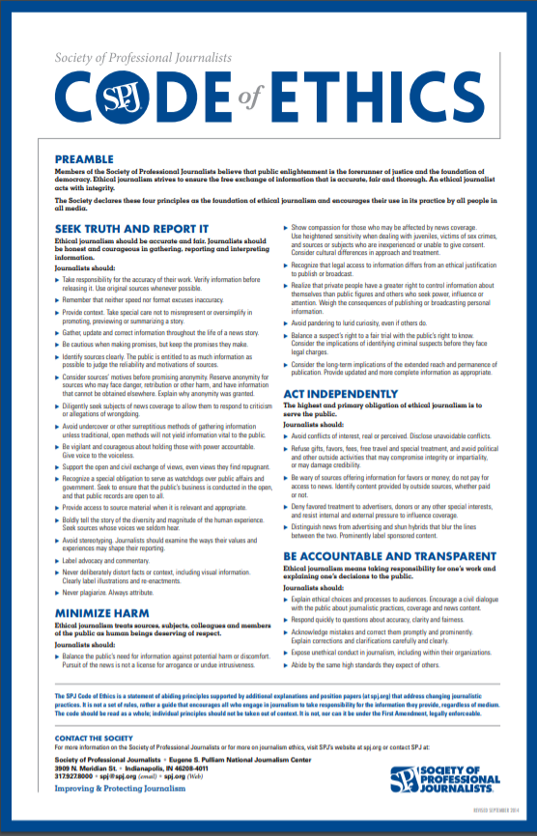

Making ethical decisions in sensitive, emotional and/or tragic events:

Some events require a great deal of extra attention when it comes to making decisions on what, where or how to capture/publish a photograph. Photographing a funeral may require added sensitivity and an awareness to your surroundings. If you’re given permission to attend a funeral, will there be restrictions on what you choose to publish? Here are some guidelines to follow:

Where | What | How
Be mindful of where you are capturing a photo. Do not intrude, especially in tragic or private moments without permission.  Example: A family grieving over the loss of a child. | Treat subjects and your environment with respect.  Ask yourself: Will this photo “do good” for the public or “do harm?” | Don’t capture a photo from using tools (long lens) that would invade someone’s privacy (through a window).
Treat your environment with respect. Don’t climb or stand on objects or structures that some may view as disrespectful. | Be aware of publishing a photo that captures a moment that some may view as disturbing or disrespectful to victims.  - Discuss this with your editor and/or adviser. | Do not manipulate or edit a photograph that will impact or alter its original content.
Do not purposefully hide in an area to conceal your camera in an area. | Ask yourself: Would publishing this photo cause harm to the subject? | Do not stage a photo unless it can be identified.
If it’s in a sensitive environment (example: funeral or crime scene), you may want to consider protecting the identity of individuals in your photo.

Remember: Some of the individuals you may capture can be victims of a crime.

Ask yourself: Would you publish a victim’s name in a story without their consent?
 | Be aware of capturing/publishing photos of children/minors, especially in private, emotional, and tragic settings.
 | Be aware of “what” you publish. If you have captured a shooting, death, crime or violent incident, discuss with your adviser whether publishing that photo would be ethical. Remember: Ask yourself, “would this cause harm?”
Camera Basics
FOCUS: Adjusting the focus on your camera allows you to control the clarity of a photo, and in some cases allows you to “focus” on a subject while leaving the remaining portion of the image “blurred.”

ISO: adjusting the ISO on your camera impacts the camera’s sensitivity to light. The slower the ISO, the less sensitive it is to light. Using slower ISO may be more suitable outdoors during a sunny day.

APERTURE: Adjusting the aperture on a camera affects how much light you let into your camera to capture an image. The wider the aperture, the more light is allowed in. This feature can be used to create depth of field in photos.

SHUTTER SPEEDS: Adjusting your shutter speed determines how long your camera’s shutter remains open. The longer your shutter speed remains open, the more light you’re going to let into your photos.

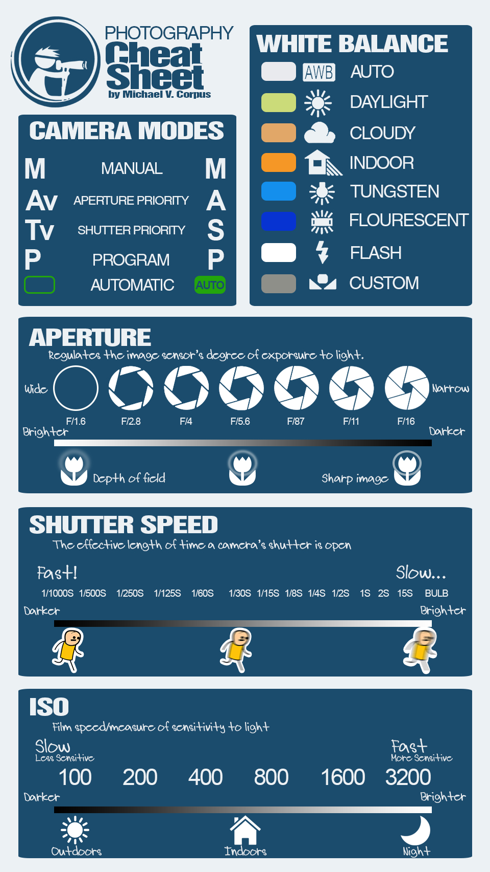
Courtesy: https://mikeroscoop.wordpress.com/2014/09/22/dslr-cheat-sheet-that-fits-perfectly-in-a-smartphone-screen/
ELEMENTS OF A GOOD PHOTO
Composition
- Composition matters. It helps to create diversity, uniqueness and creativity to your photos.

LIGHTING
- Just like composition, lighting matters. Using different lighting techniques can change the way your photo looks and the story it shares with readers.

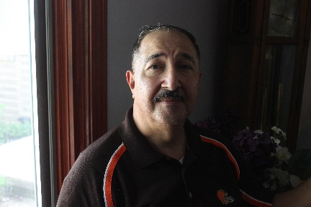

SHOOTING EVENTS
TIPS:
- Be prepared
  - If you know you’re going to shooting outside, analyze the possible lighting situations you’ll be in or what you’ll need. Do you know where you’ll be going?
- Request credentials, permission for private events
  - Not requesting the proper credentials or permission can leave you and your camera in the dark on event day.
- Make sure to ask for the names of the people in your photos. It’s good to ask permission and for the correct spelling of the names.
- Tell a story
  - Shoot your photos as if you’re telling a story. Could a viewer understand the story by simply looking at your photos and captions?
SHOOTING SPORTING EVENTS
TIPS:
- Be prepared
  - Be prepared for the unexpected. You won’t be able to plan your shots, but you can be prepared for what might happen. Use the continuous mode on your camera to help you capture action shots.
- Getting the right lens:
  - If you know you’ll be shooting from far away, make sure you have a long lens to capture the action.
- Action vs. Reaction
  - While you may be waiting for the action, capturing the reaction could be just an impactful – if not more. Capturing a reaction can help tell a story of triumph or loss. Be sure to keep your camera close after winning shot.

PORTRAITS
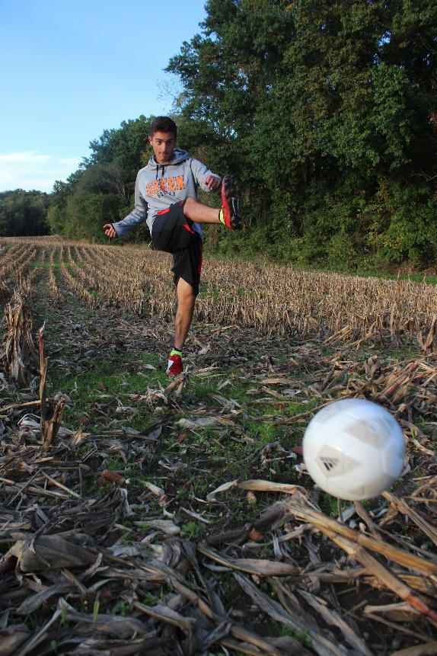
TELLING A STORY
Taking photos of individuals can seem straight forward. But there’s more to a photo of someone than just a “mug shot.” Portraits can tell a story.
TIPS:
- Use your surroundings to help tell the story. What are you trying to capture? Are they an athlete? Ask your subject to show you something they can do. Capture their body language through their actions or their emotion.
- What’s the story? Develop an understanding of your subject and what they’re trying to say. If there’s a place that stands out to them, have them take you there and share stories. Capture the walk-and-talk as opposed to having them stand in front of something looking directly at the camera.

CAMERA HANDLING
Checking out your camera:
- Request the equipment sign-in sheet in the newsroom.
- Each piece of equipment will be labeled with its own number. Mark down the number of the equipment that you will be using, including the date you will be returning the items.
- Sign your name and return the sheet to the proper location.
TIPS:
- When handling your camera make sure to keep the equipment in its baggage/case when not in use.
- Replace the lens cap when your camera is not in use.
- Grip the camera with your right hand and place your index finger on the shutter release, grasping the bottom of the lens with your left hand for support. Your left hand should act as a tripod. Rest your left elbow on your rib cage for additional support.
- If you’re taking a photo at ground level, place your elbows or knee on the ground for added support.
- Two hands: (grip camera handle with right hand, use left hand to hold the bottom of the lens and anchor your elbow on your rib cage for additional support and stability.)
- Elbows: (keep elbows close together near your torso to help create additional support.)
- Eyebrows: (Bring your forehead close to the camera, lining up your eyebrows with the viewfinder for additional stability.)
- Legs: (Put one foot slightly forward to help with balance.)

PHOTO EDITING
Editing should NOT be used to manipulate a photo. You should limit editing to making minor adjustments to enhance the quality of a photo without manipulating its content.

Editing Photos:
- Students will use Photoshop to make any necessary edits to their photos. This may include:
  - Cropping
  - Enhancements:
    - Brightness, color
  - Resizing
CAPTIONS/CUTLINES
- What does a cutline provide to a story?
  - Cutlines are used to help identify the subjects in your photo, as well as provide additional details (including date and location) and context for the reader.
  - Cutlines should be written by the photographer who captured the image. The cutlines are then reviewed by the photo editor before it’s moved through publishing.
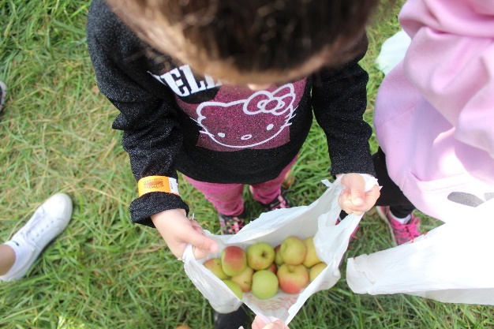

Sophia Abraham, 4, counts the apples she picked during a family outing at Great Country Farms in Bluemont, VA on Oct. 20, 2018. The apples, along with sunflowers at a field nearby, will be available for picking through the month of October.

ARCHIVING PHOTOS
Save photos in the designated folders as requested by your adviser. Each photo should be uploaded with the corresponding metadata, including cutlines, photographer’s name and date.
Follow the steps below in Photoshop:
Step 1:
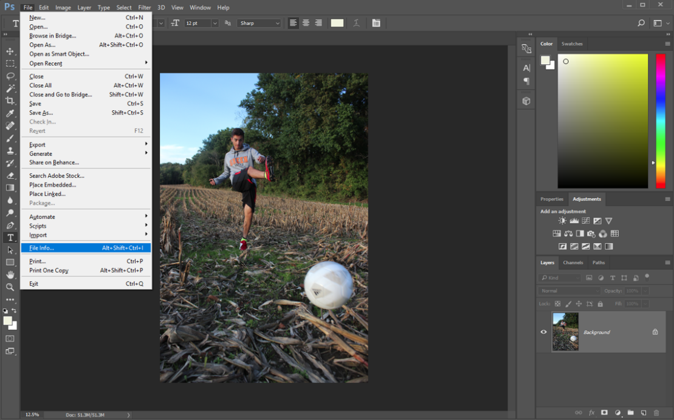
Step 2:
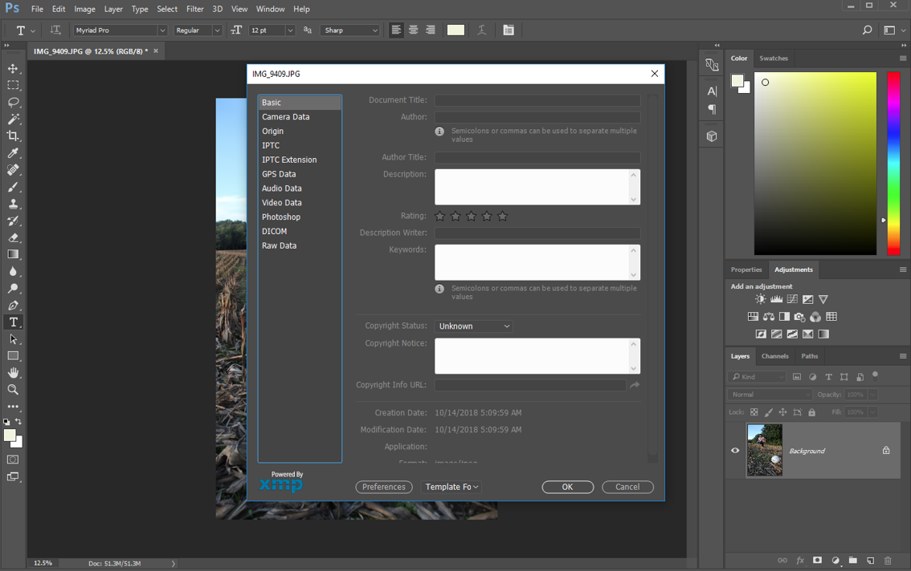
Step 3:
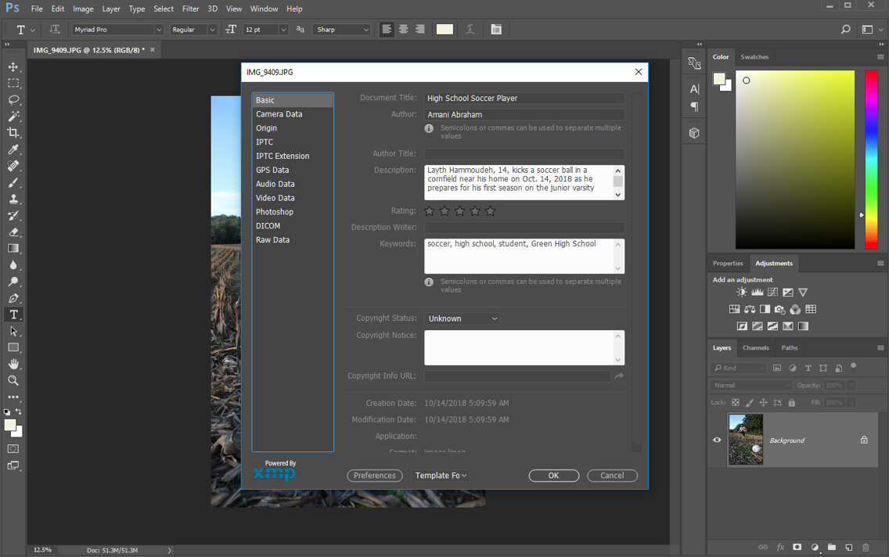:
Step 4:
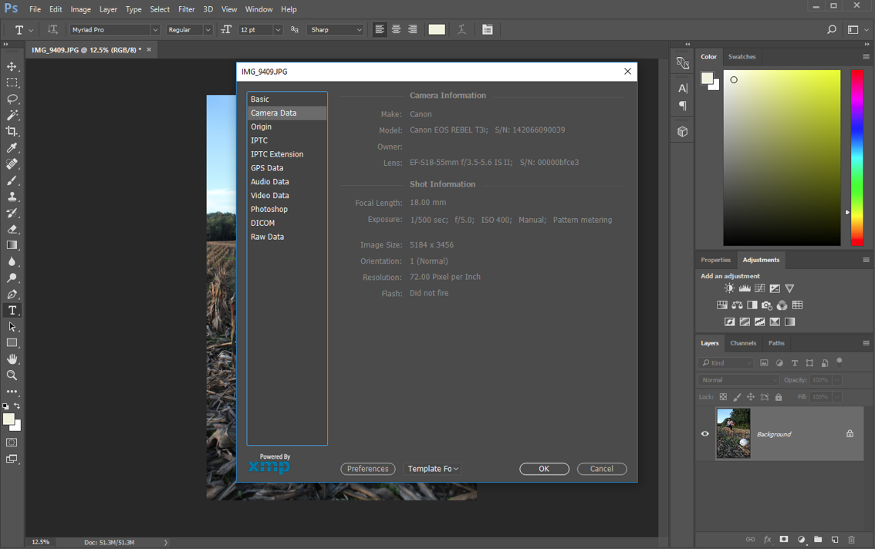

Step 5:
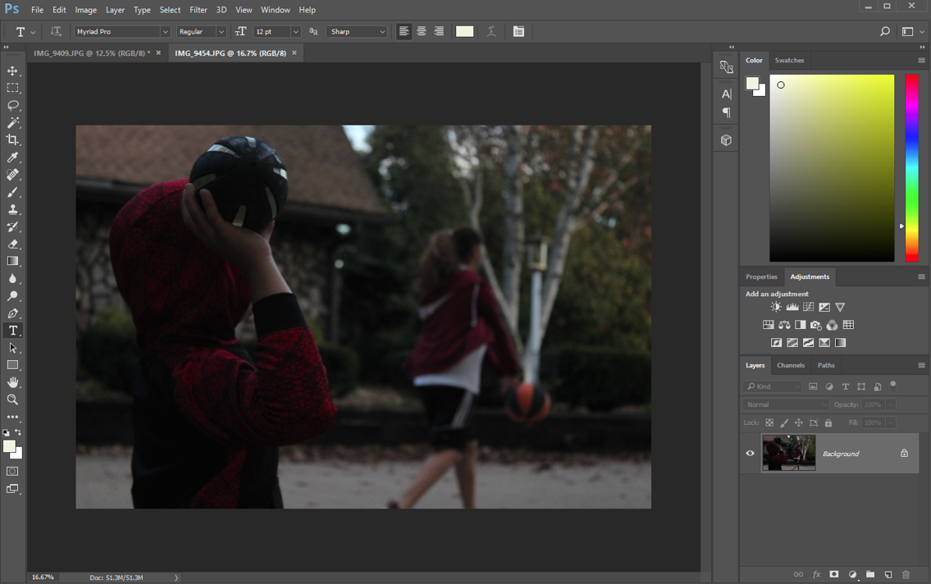
Step 6:
