Staff Hierarchy and Descriptions
Adviser
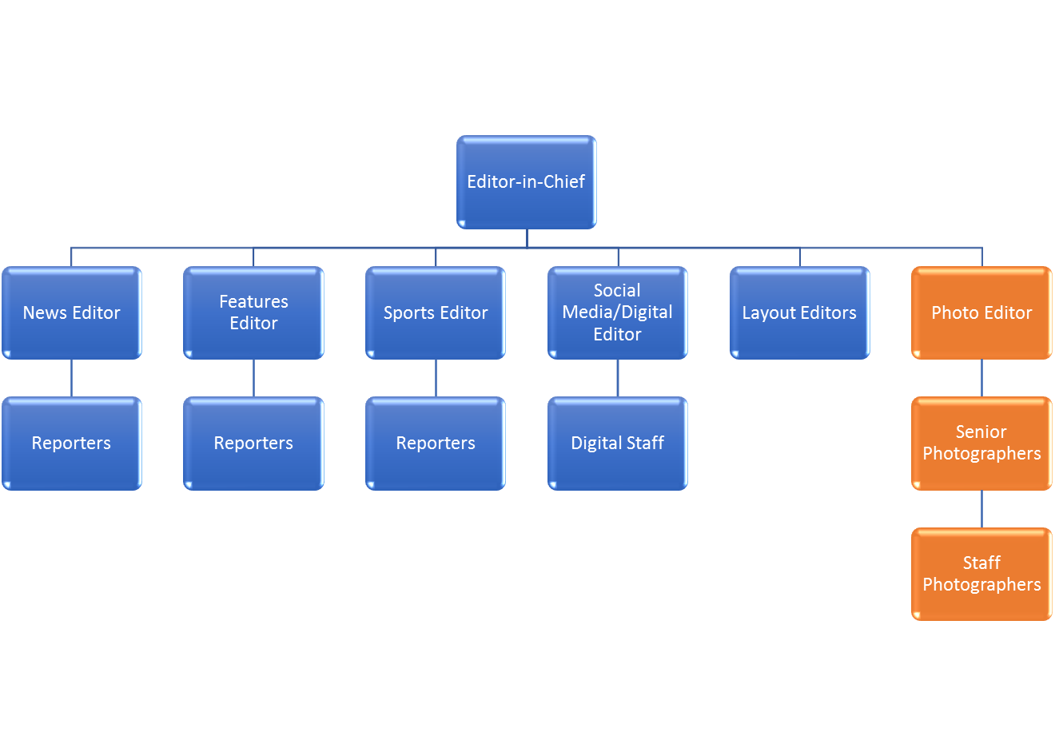

Editor-in-chief
- Responsible for final approval of stories before it’s published, which includes final edits, headlines and photo captions.
- Editor-in-chief will help to assign and guide story ideas when needed.
- Organize and manage staff and deadlines for publication.
- Responsible for editor’s notes on publications in the case of corrections to errors in publication.

News Editor
- Responsible for assigning weekly story assignments, which can include breaking news.
- Lead daily/weekly news meeting with assistance of editor-in-chief.
- Responsible for advising reporters on upcoming stories and assigning deadlines.
- Responsible to review interview questions.
- Responsible for first edits of stories and subsequent revisions.

Features Editor
- Responsible for assigning weekly story assignments.
- Responsible for first edits of stories, interview questions and subsequent drafts.
- Responsible for advising reporters on upcoming stories and assigning deadlines.

Sports Editor
- Responsible for assigning weekly story assignments.
- Responsible for first edits of stories, interview questions and subsequent drafts.
- Responsible for advising reporters on upcoming stories and assigning deadlines.

Social Media/Digital Editor
- Responsible for overseeing the digital push of stories on social media accounts, including but not limited to Facebook, Twitter and Instagram.
- Responsible for checking with reporters on digital elements that can be incorporated into stories including video, audio and photo slideshows.
- Responsible for monitoring and responding to social comments on stories and published elements.

Layout Editors
- Responsible for the design of each page within an online publication.
- Responsible for assigned pages and coordinating layout with reporters/editors.
- Confirms final design layout with editor-in-chief.

Reporters
- Responsible for completing interview and completed stories by expected deadlines.
- Keeps recorded interviews and notes organized to help confirm information in stories if needed by editor-in-chief.
- Completes one story per month, or as designated by editor-in-chief.
- Generate at least one multimedia element (photograph, video or podcast/audio) for each story when ready to publish online.
- Submits ideas for stories on a weekly basis.

Digital Staff
- Responsible for posting and organizing stories on social media pages.
- Responsible for partnering with reporters/editors to secure timely social media posts, teases and multimedia elements.
- Monitors comments, issues, errors on social media pages.

Photo/Multimedia Editor
- The photo/multimedia editor(s) is responsible for assigning and reviewing images/video/audio for publication.
- Responsibilities include mentoring photographer/videographers and helping to reinforce ethical and responsible journalism.
- The editor is responsible for reviewing photo, edits made and the final cutline that will be used in publication.

Photographers/Videographer
- Staff photographers are required to complete assignments as requested through the guidance of senior photographers and photo editor(s).
- Photographers are responsible for capturing photo, editing and writing cutlines
- Final edits and approval are made by editor(s).

