UPLOADING on SoundCloud

- Open SoundCloud and click on “upload” on the top right of the screen.

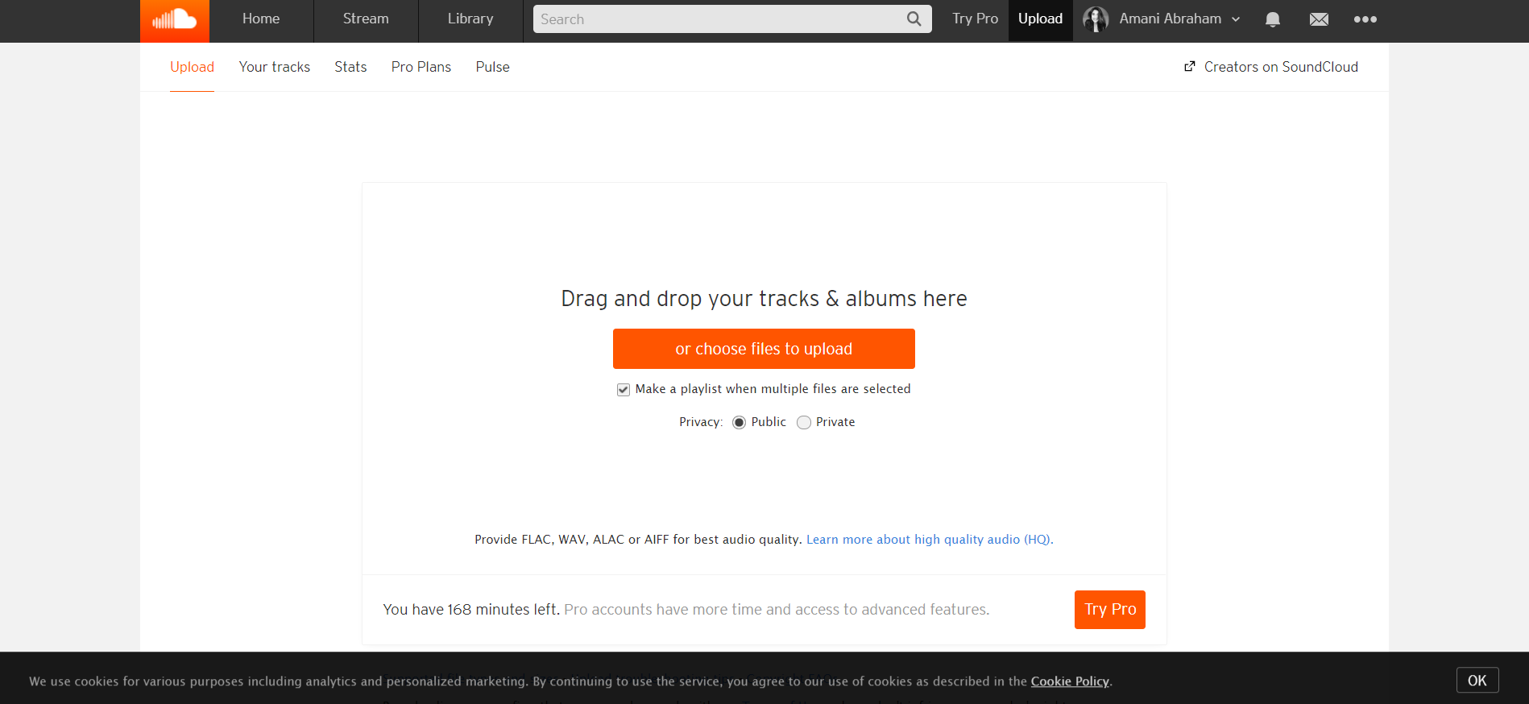

2. Find your file and click open.
------------------
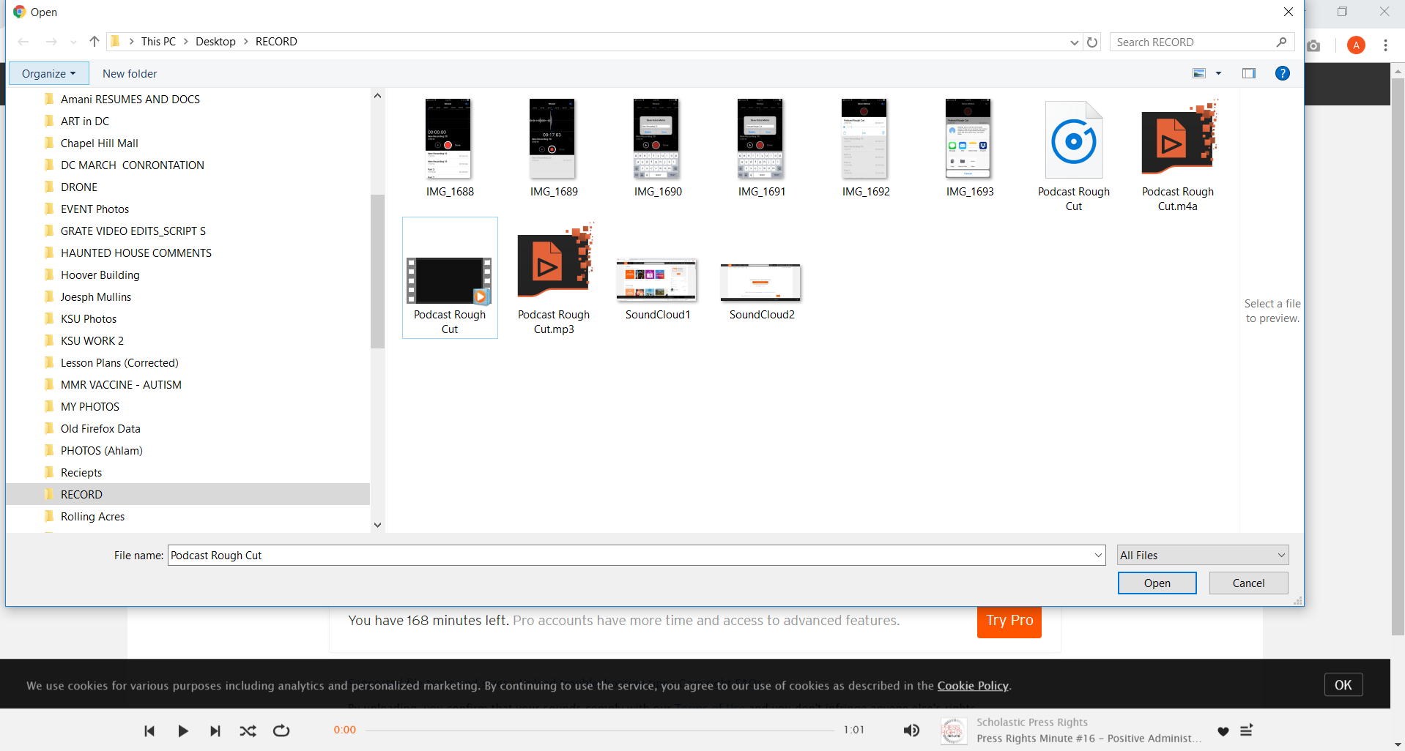

3. Begin naming your audio file and add a category. Be sure to add tags and a description to the audio file and click save.


